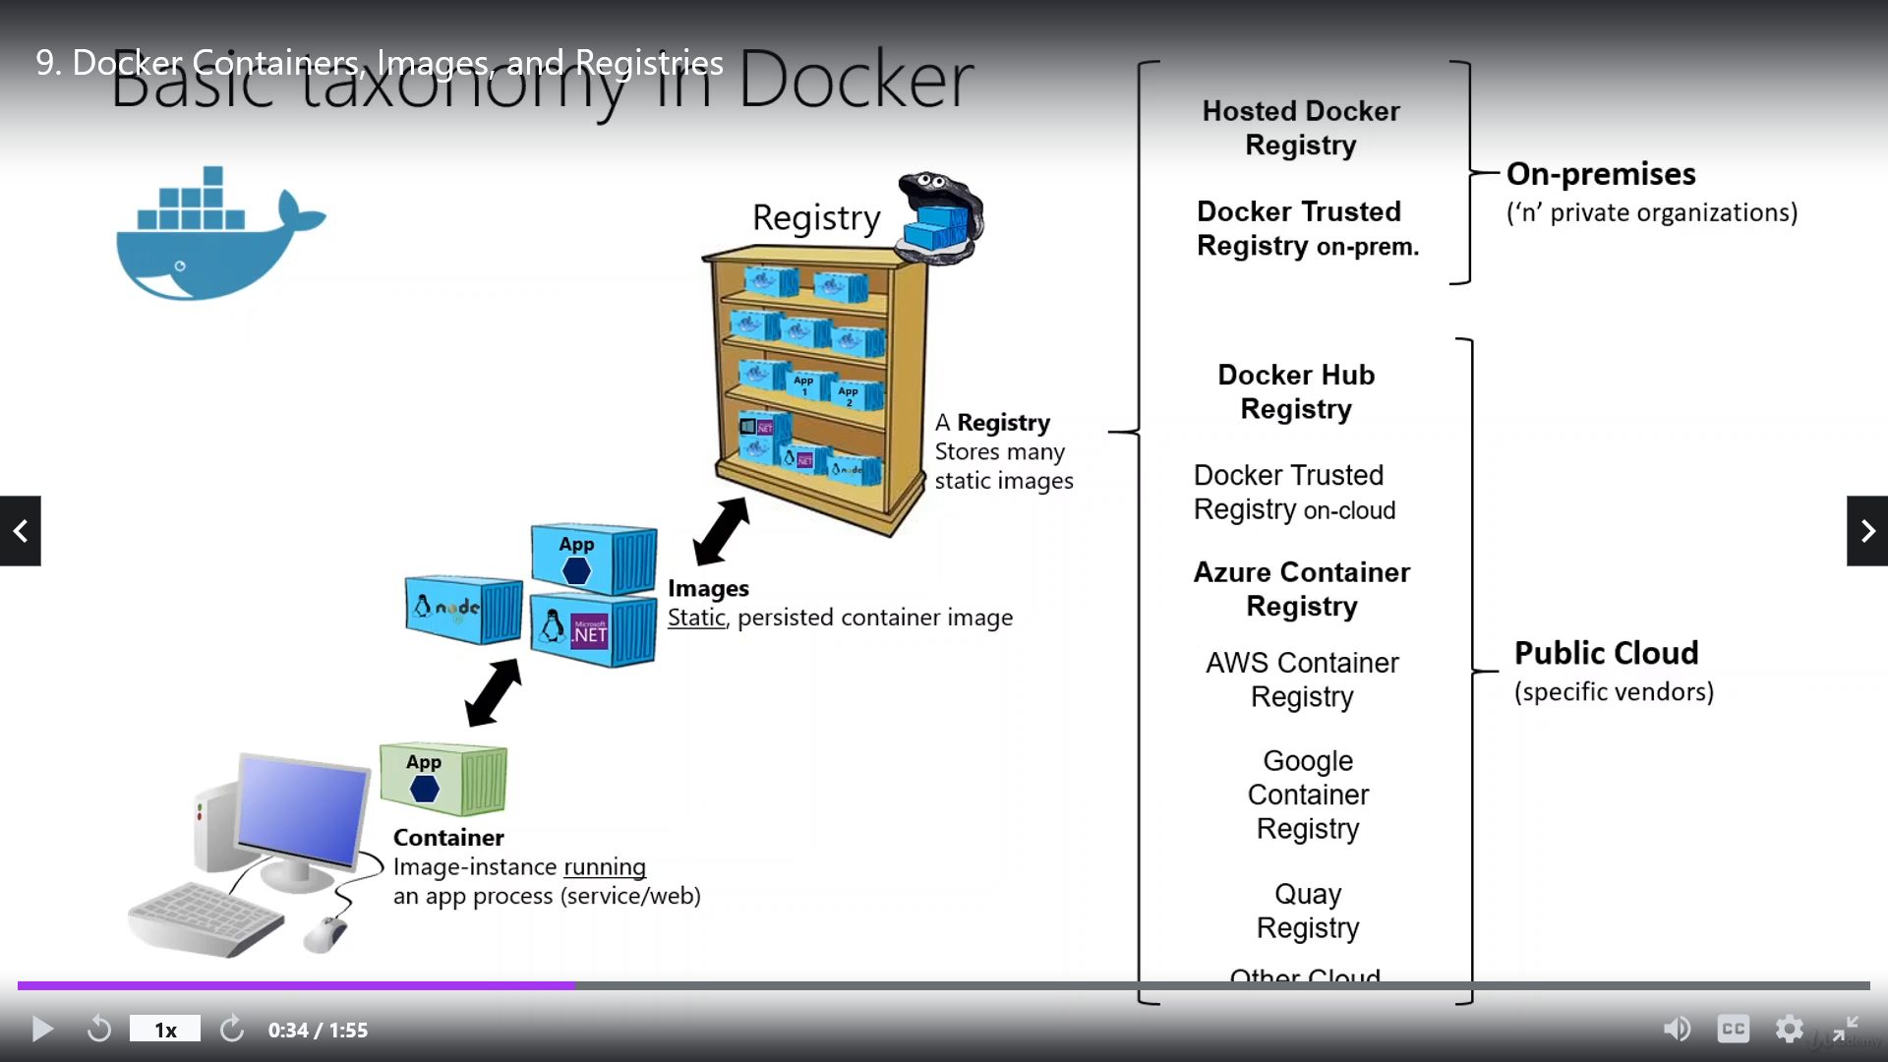

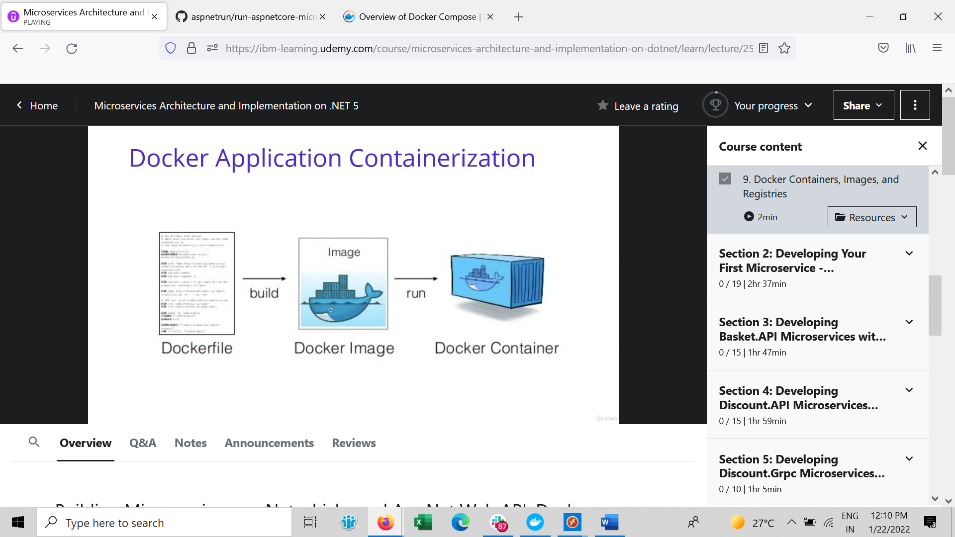

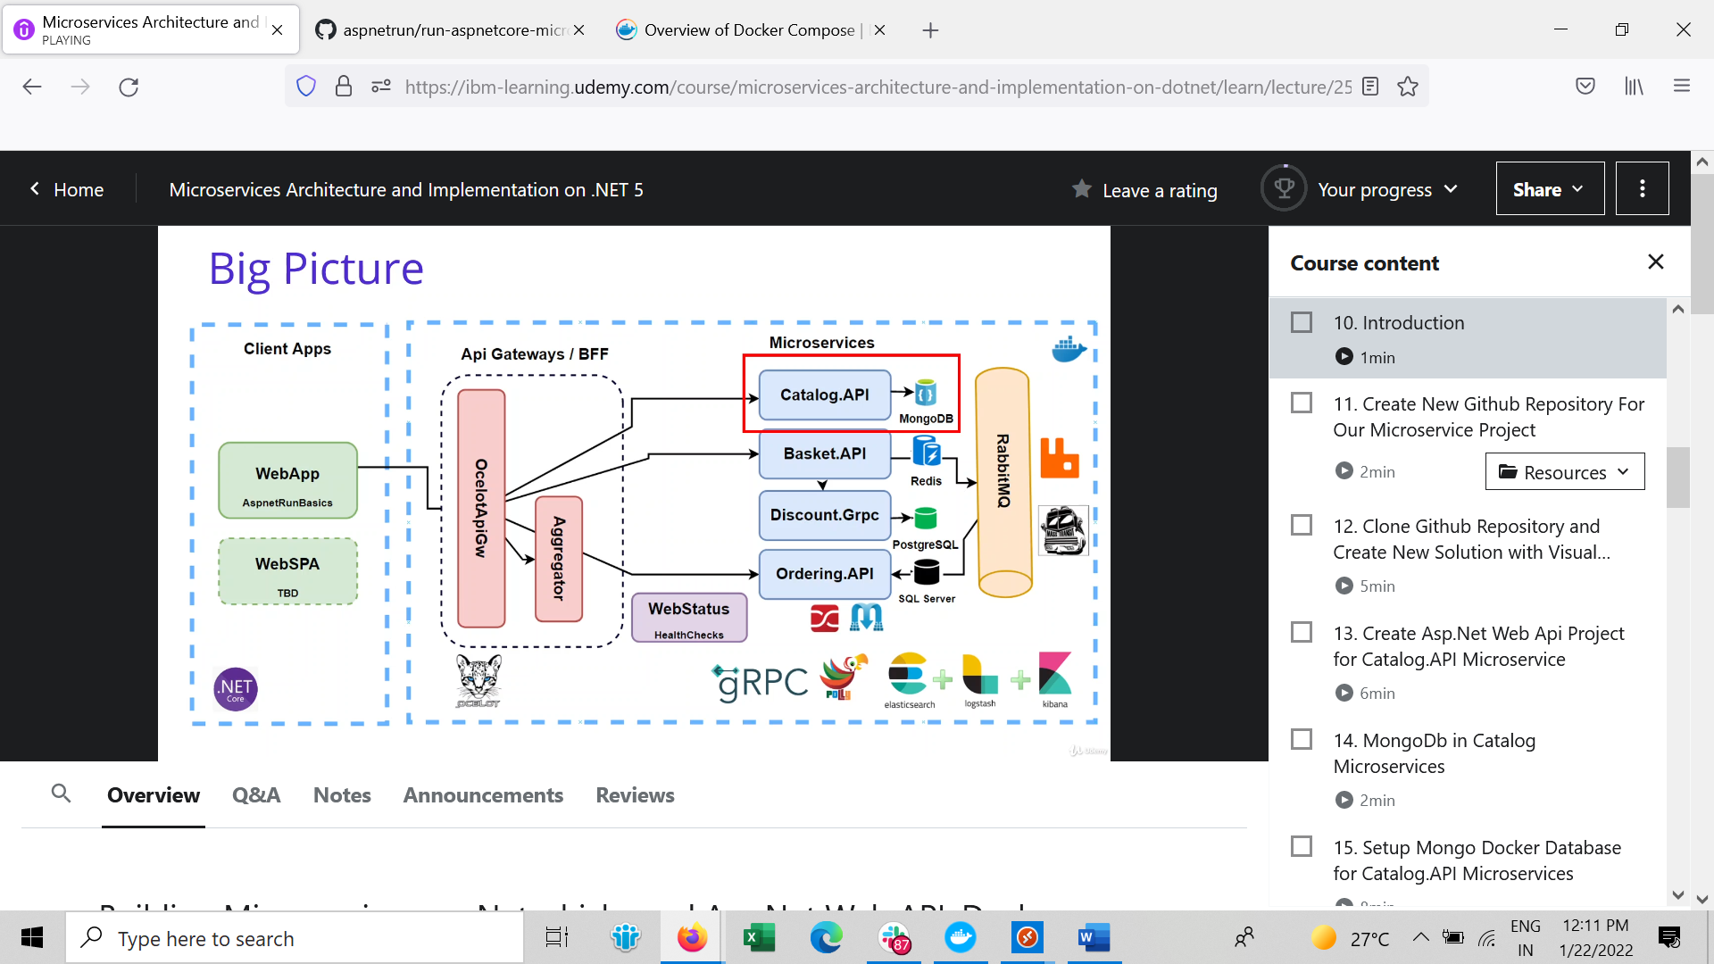

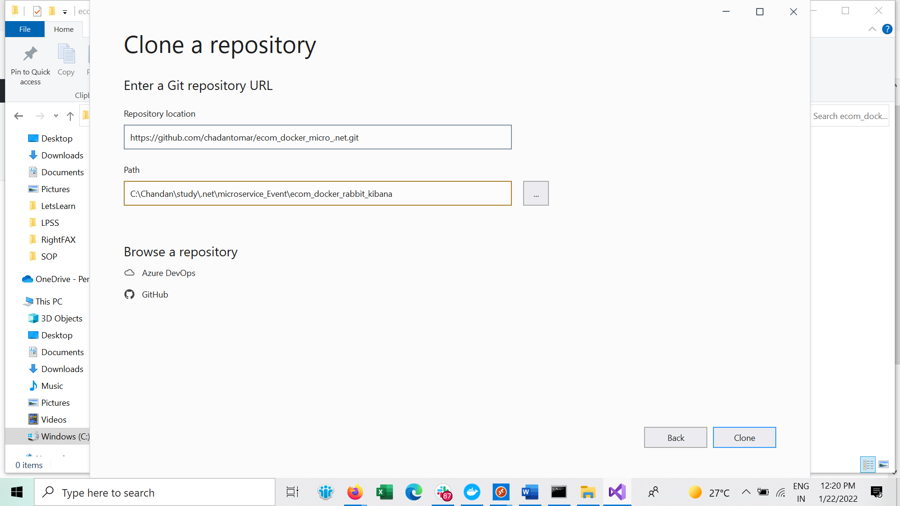

1. Create MongoDb setup

Hub.docker.com

docker pull mongo

docker run -d -p 27012:27012 --name shopping-mongo mongodocker run -d -p 27012:27012 --name shopping-mongo mongo

* Docker ps

docker exec -it shopping-mongo /bin/bash

s

mongo

show dbs

use CatalogDb --> for create db on mongo

db.createCollection('Products') --> for create people collection

db.Products.insertMany([{ 'Name':'Asus Laptop','Category':'Computers', 'Summary':'Summary', 'Description':'Description', 'ImageFile':'ImageFile', 'Price':54.93 }, { 'Name':'HP Laptop','Category':'Computers', 'Summary':'Summary', 'Description':'Description', 'ImageFile':'ImageFile', 'Price':88.93 } ])

db.Products.insertMany(

[

{

"Name": "Asus Laptop",

"Category": "Computers",

"Summary": "Summary",

"Description": "Description",

"ImageFile": "ImageFile",

"Price": 54.93

},

{

"Name": "HP Laptop",

"Category": "Computers",

"Summary": "Summary",

"Description": "Description",

"ImageFile": "ImageFile",

"Price": 88.93d

}

])

db.Products.find({}).pretty()

db.Products.remove({})

show databases

show collections

db.Products.find({}).pretty()

Now will create Catelog DB in MongoDB

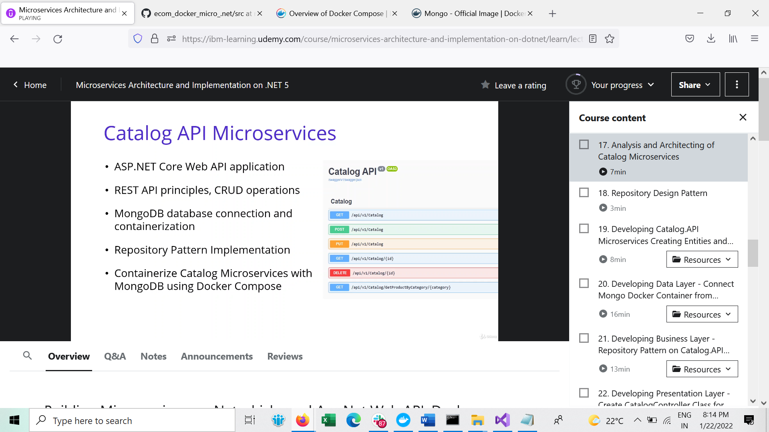

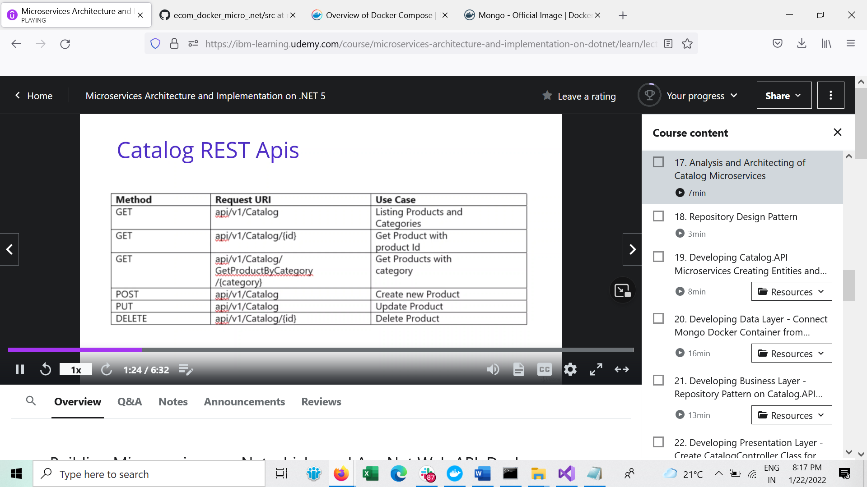

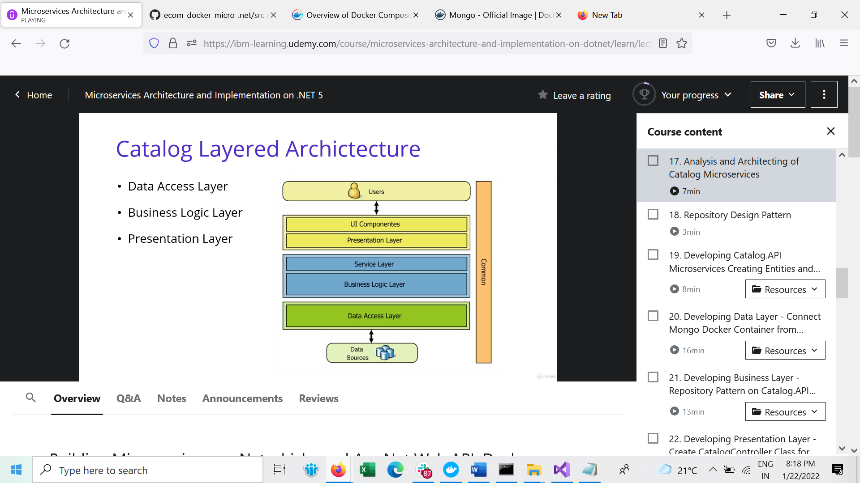

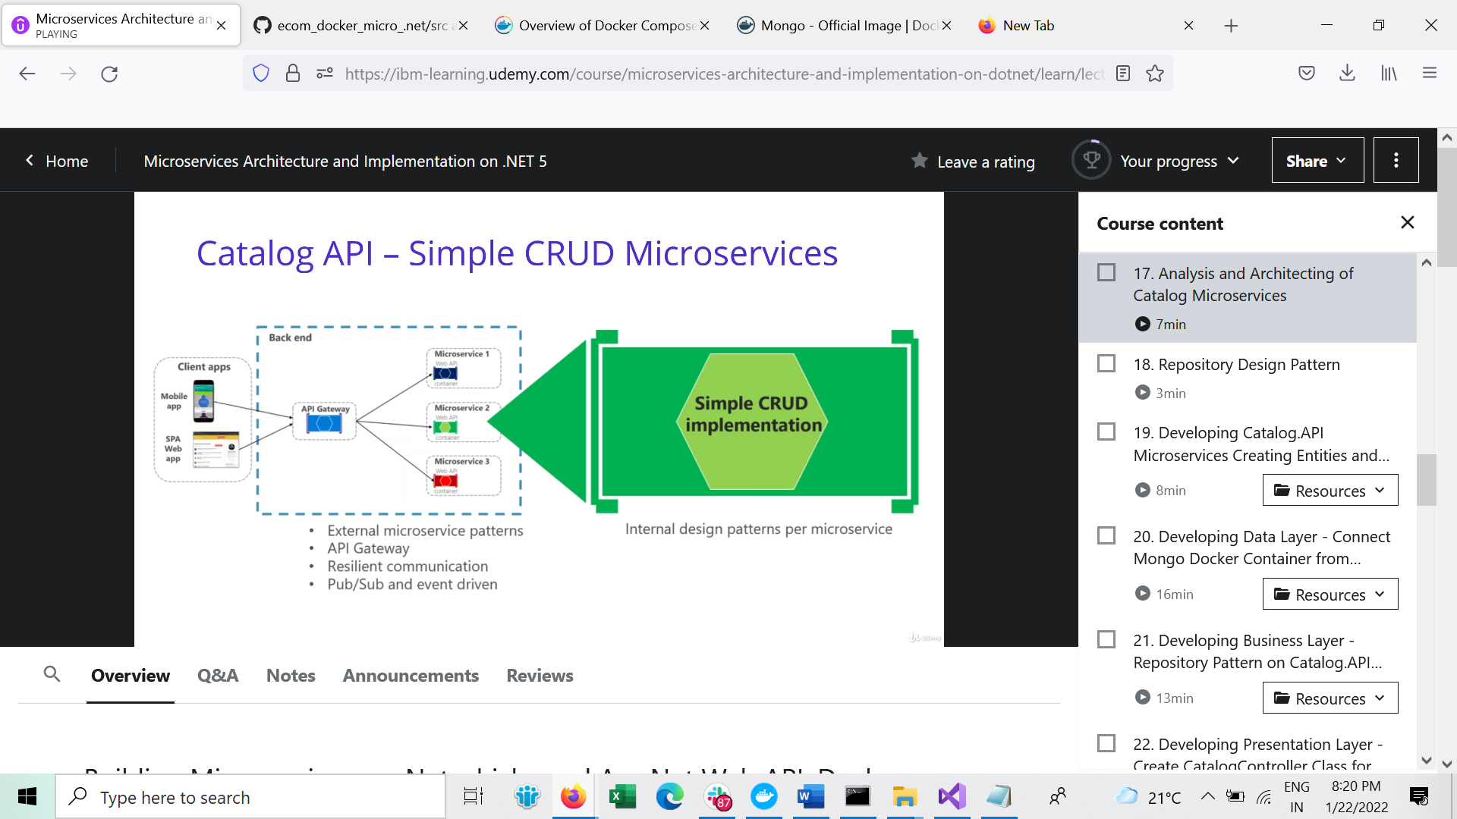

Will use MongoDB.Driver to communicate mongoDb

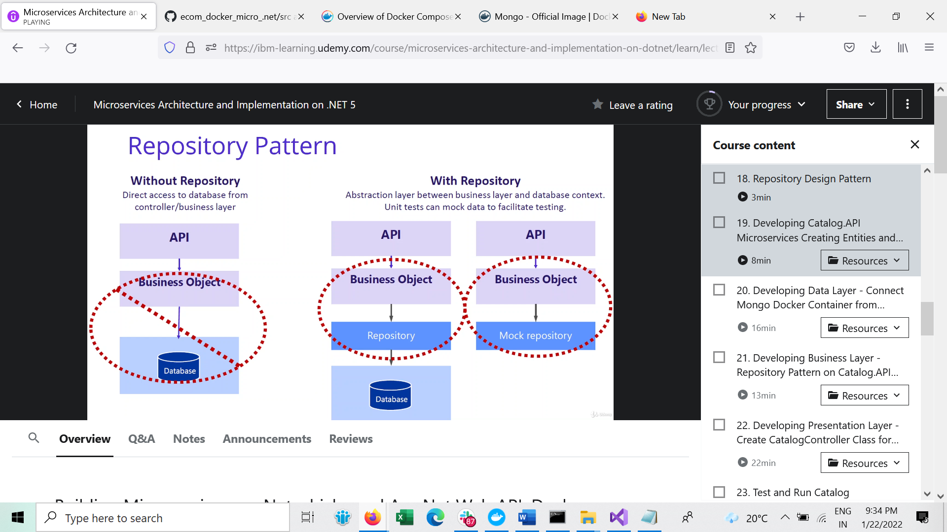

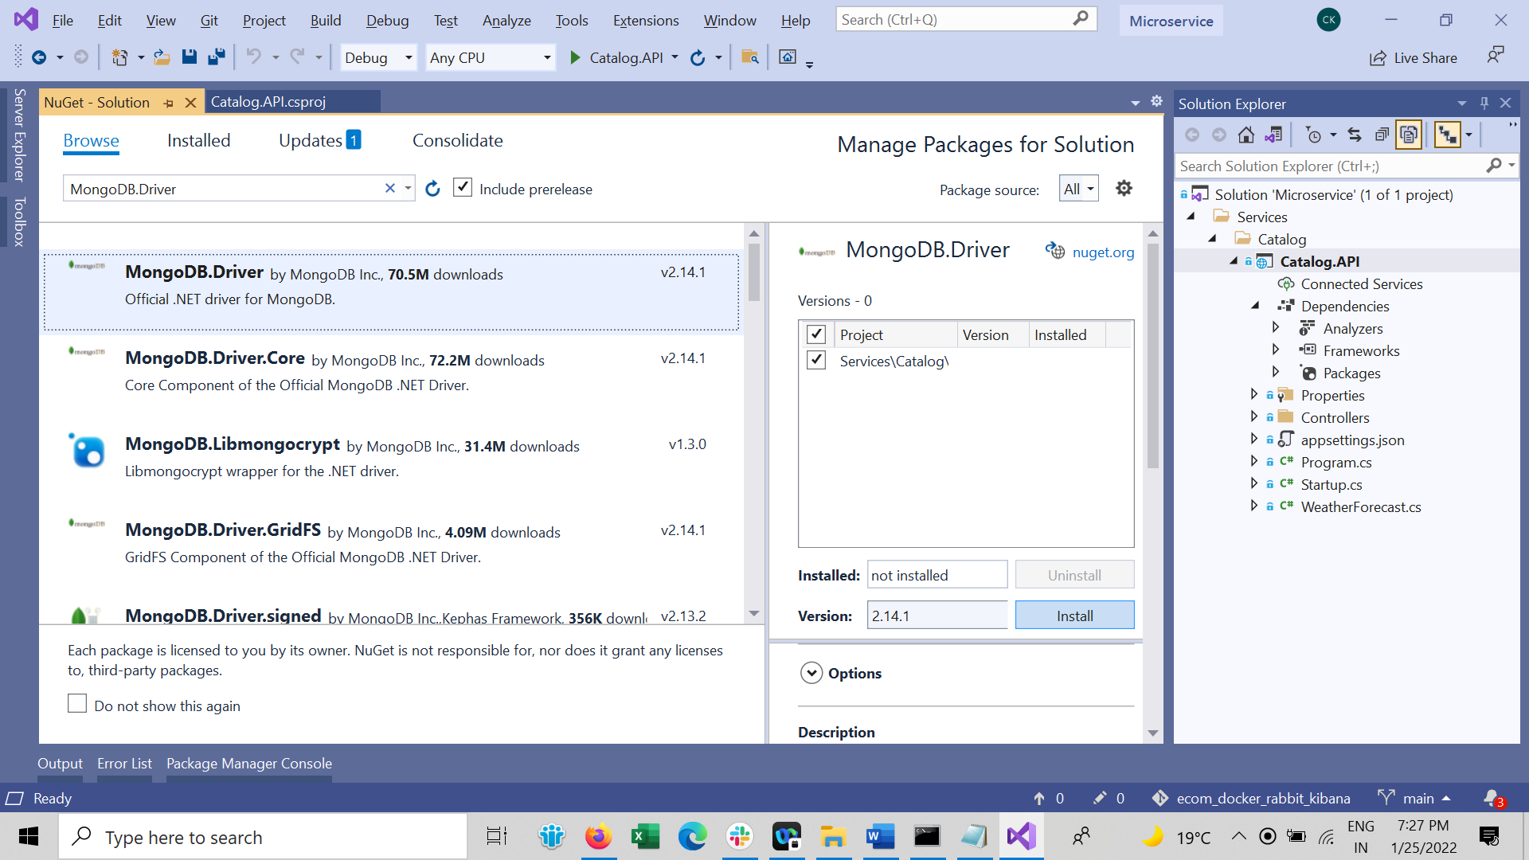

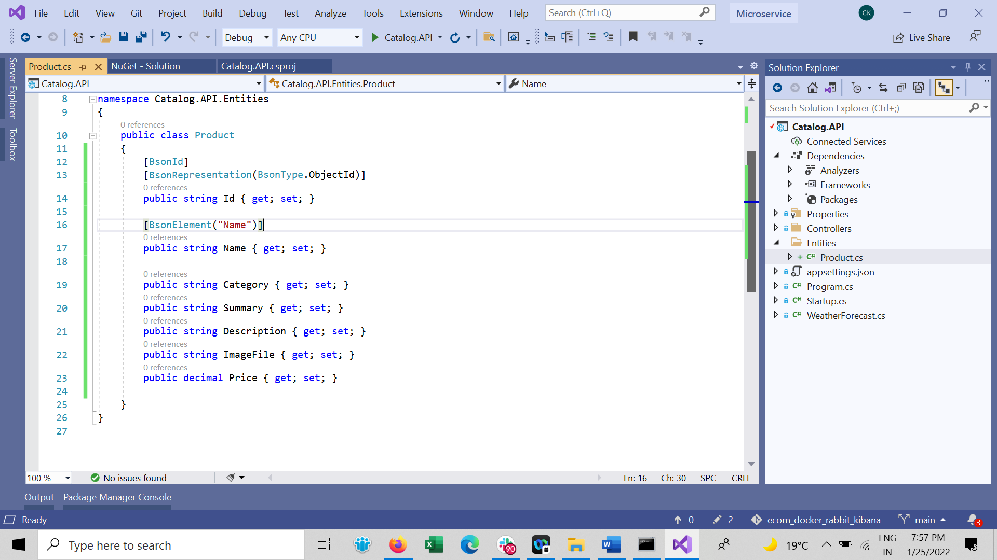

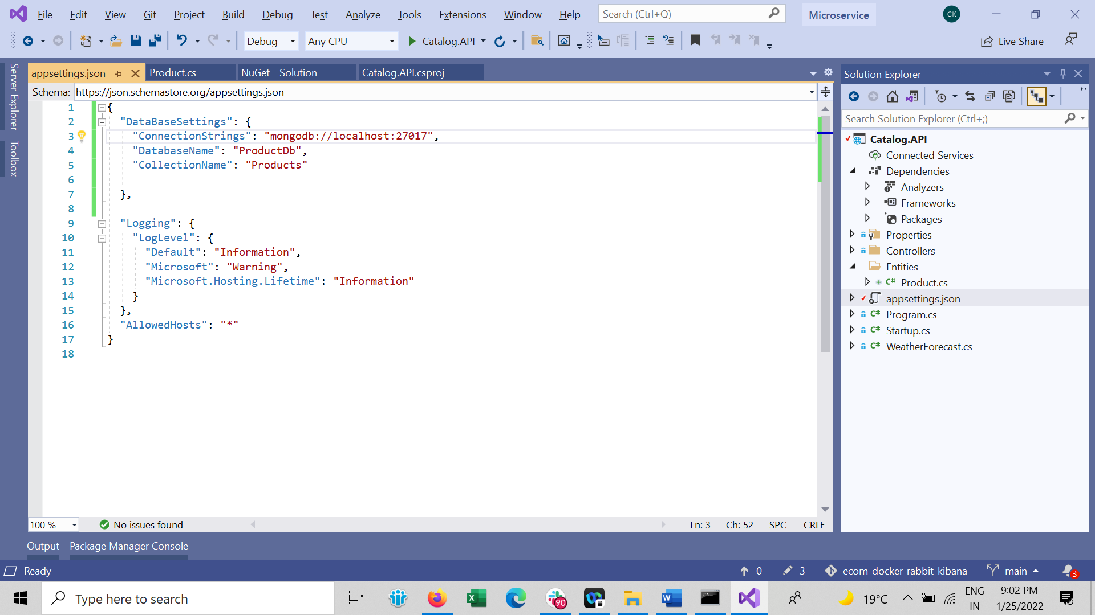

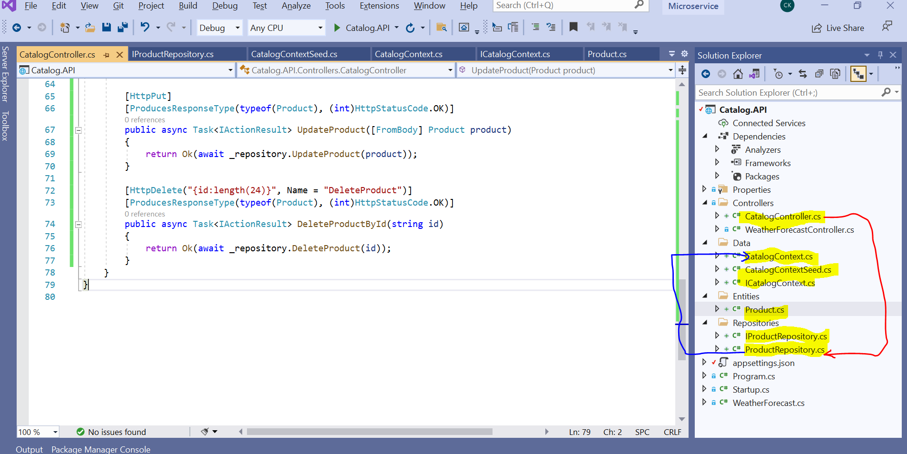

Add in Startup.cs configure CatalogConext and ProductRepository

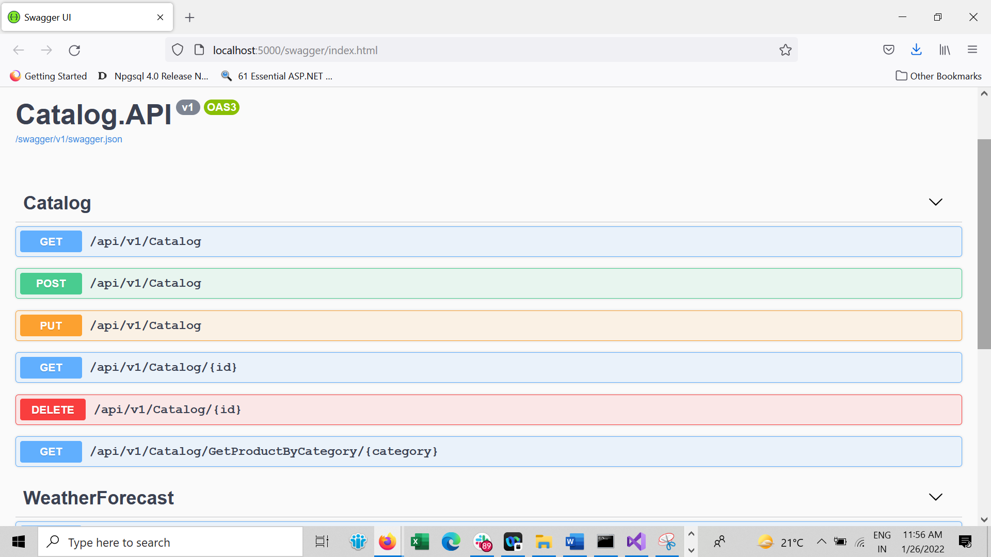

Check at Docker Db container

docker exec -it shopping-mongo /bin/bash

use ProductDb

db.Products

db.Products.find({})

Now Docker Compose

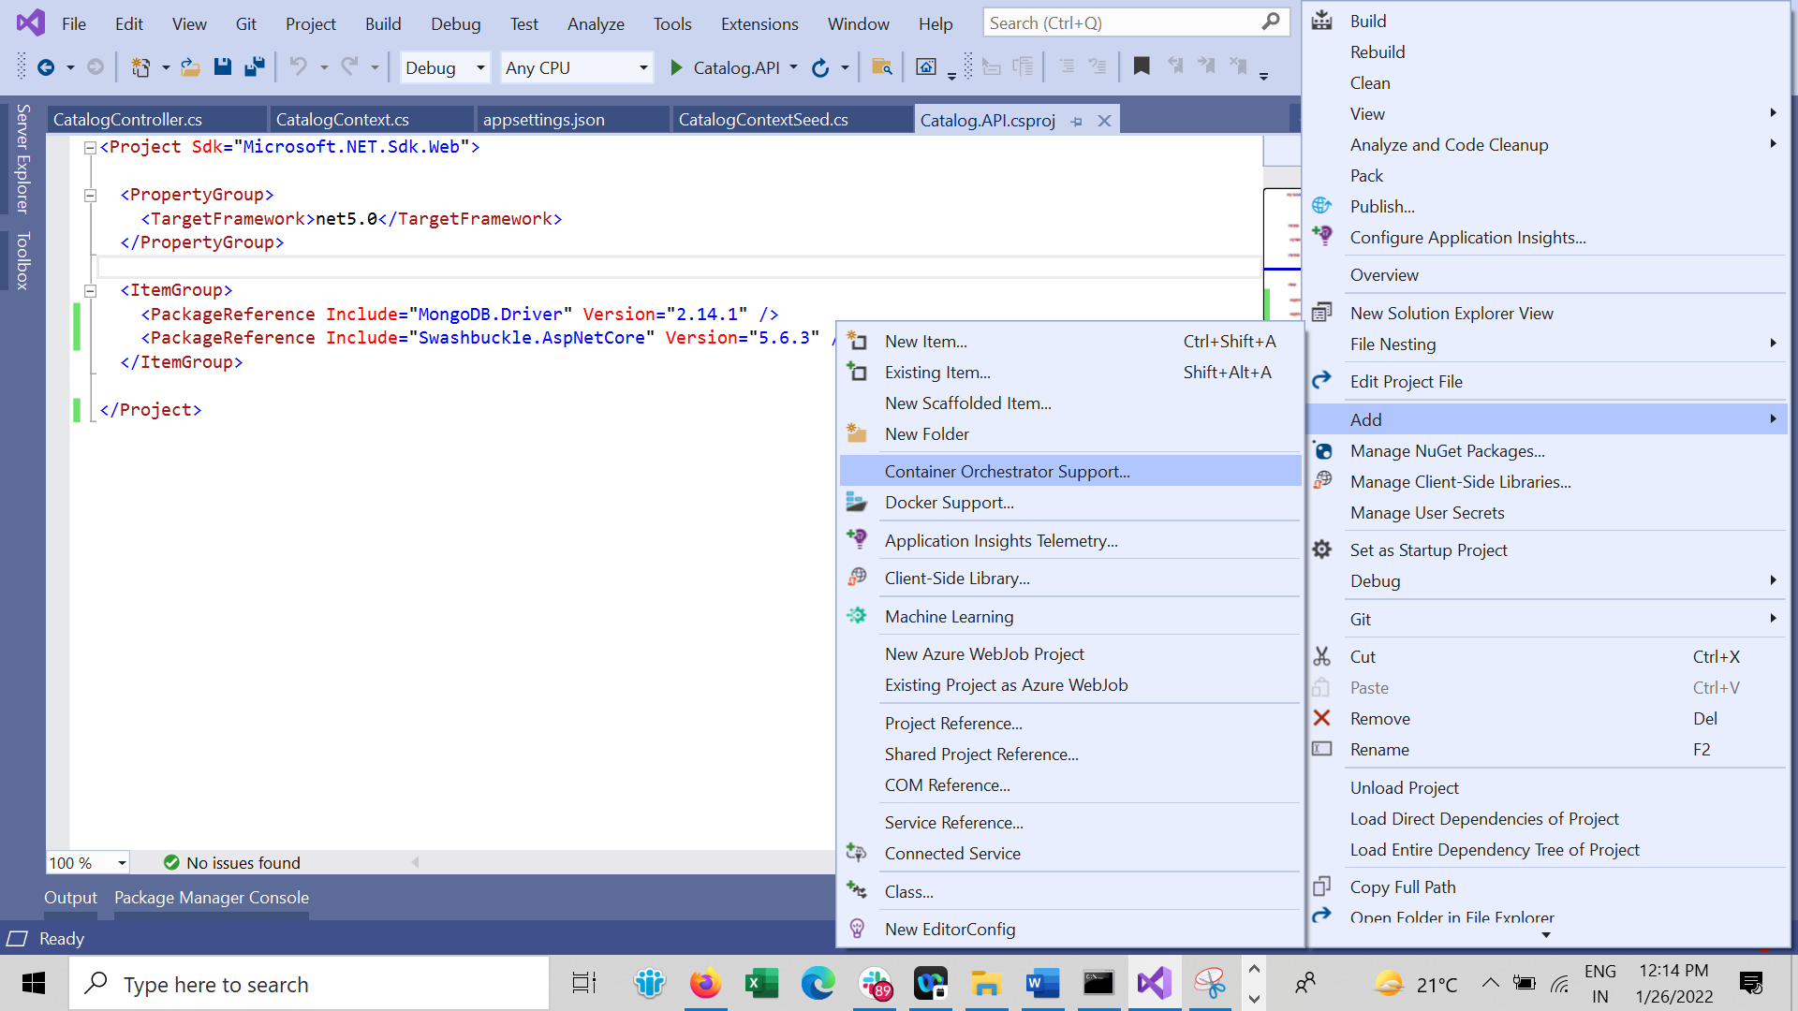

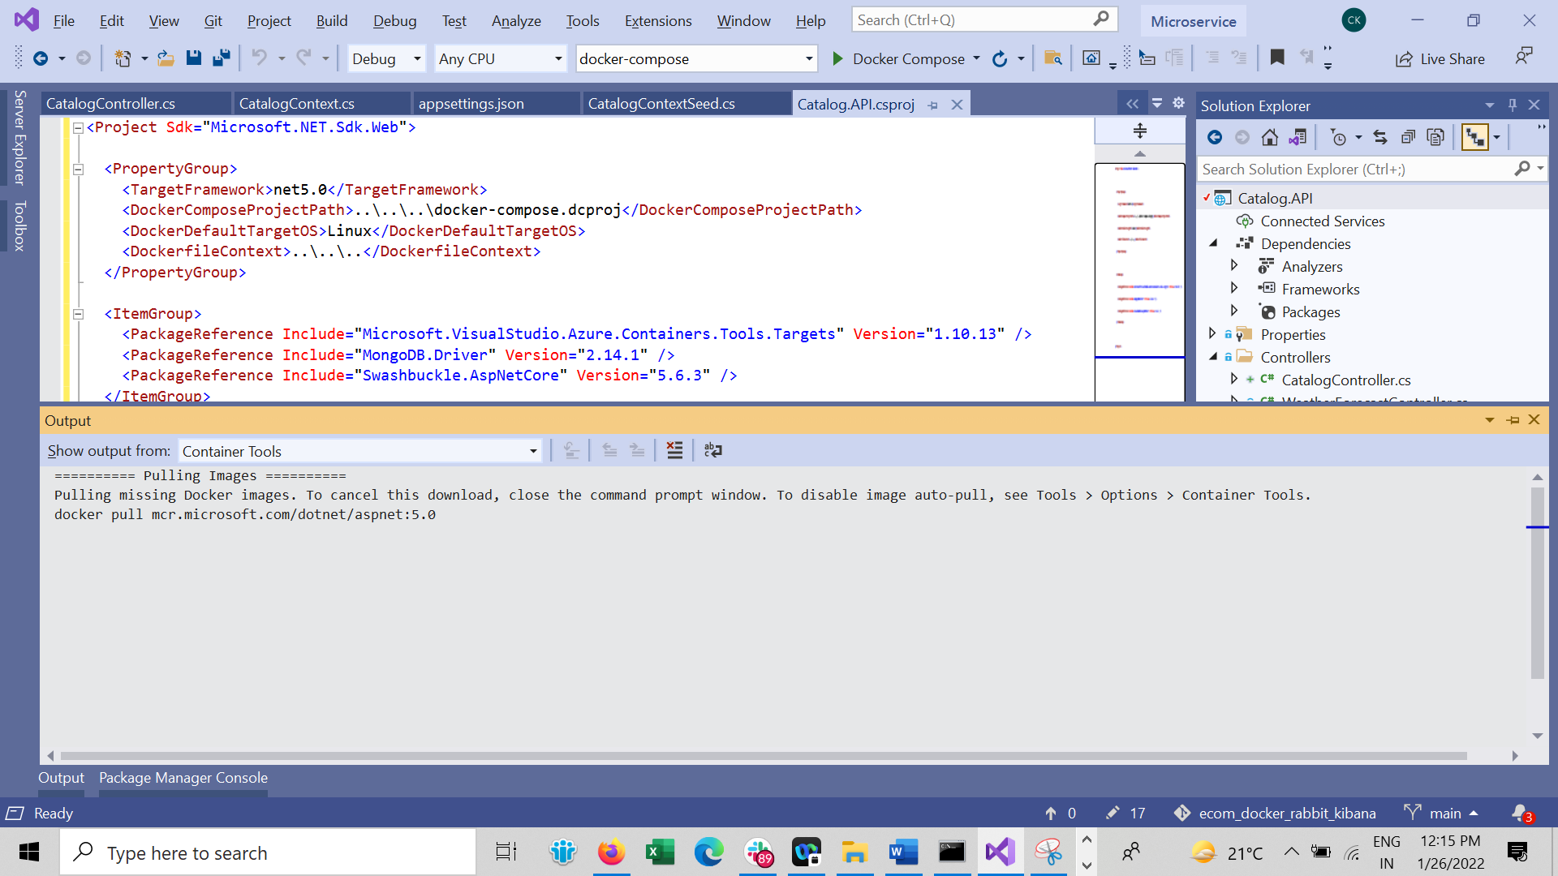

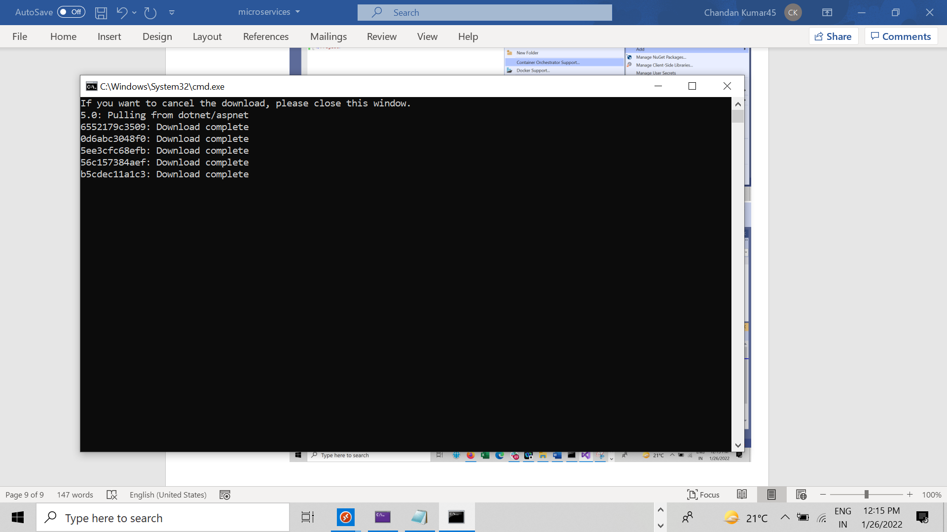

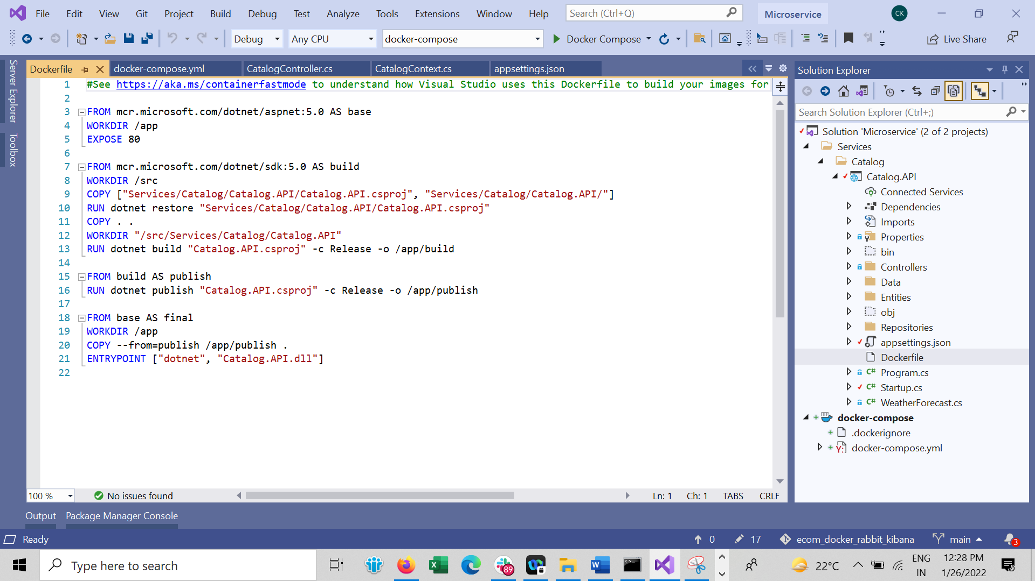

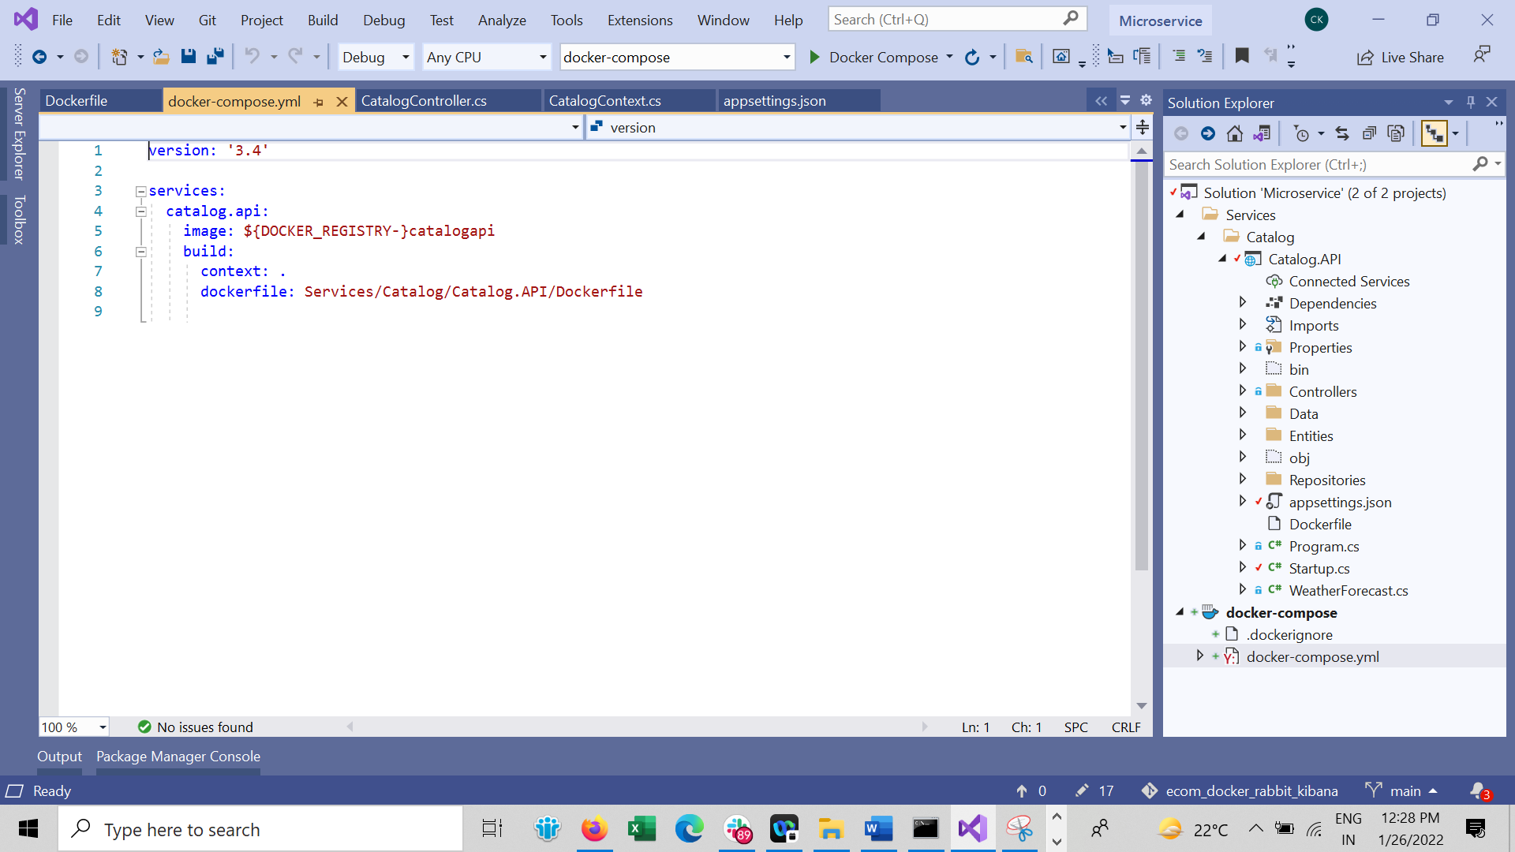

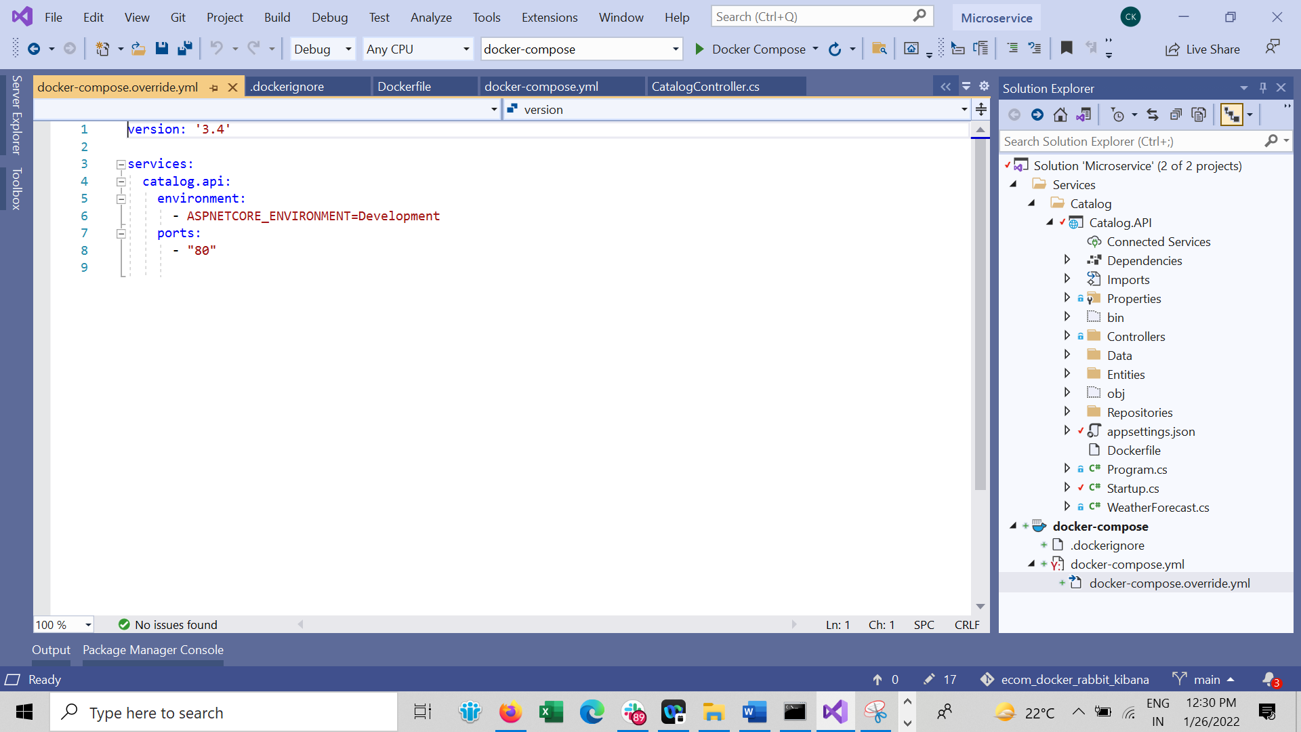

Now add Mongo DB in Docker compose

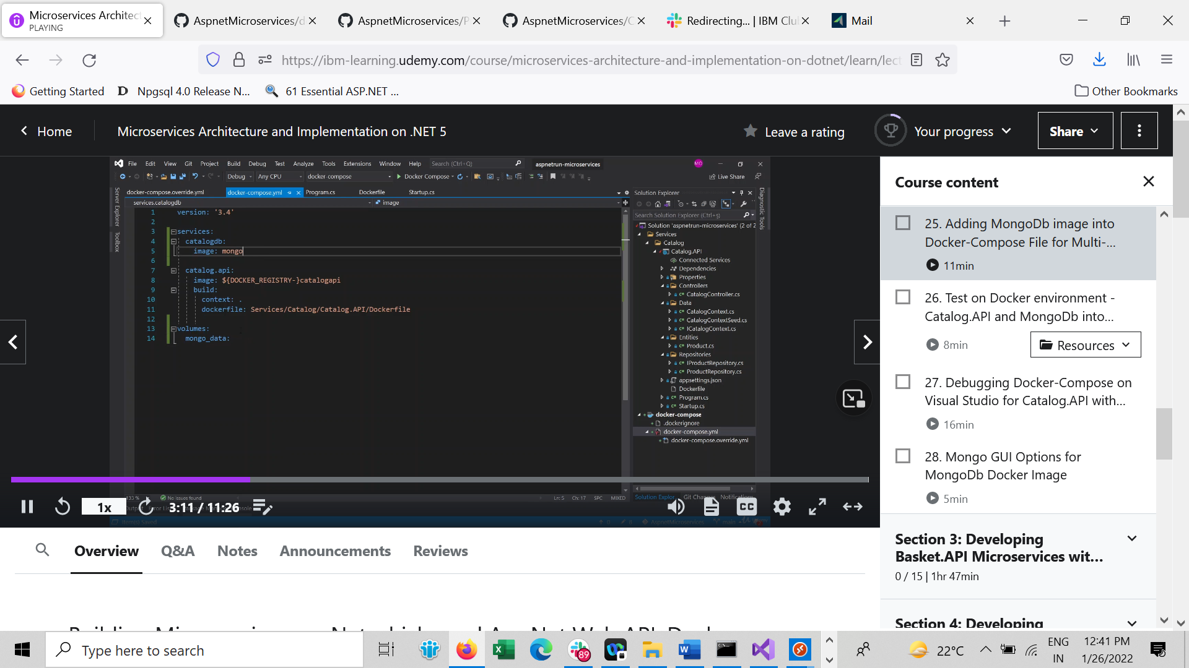

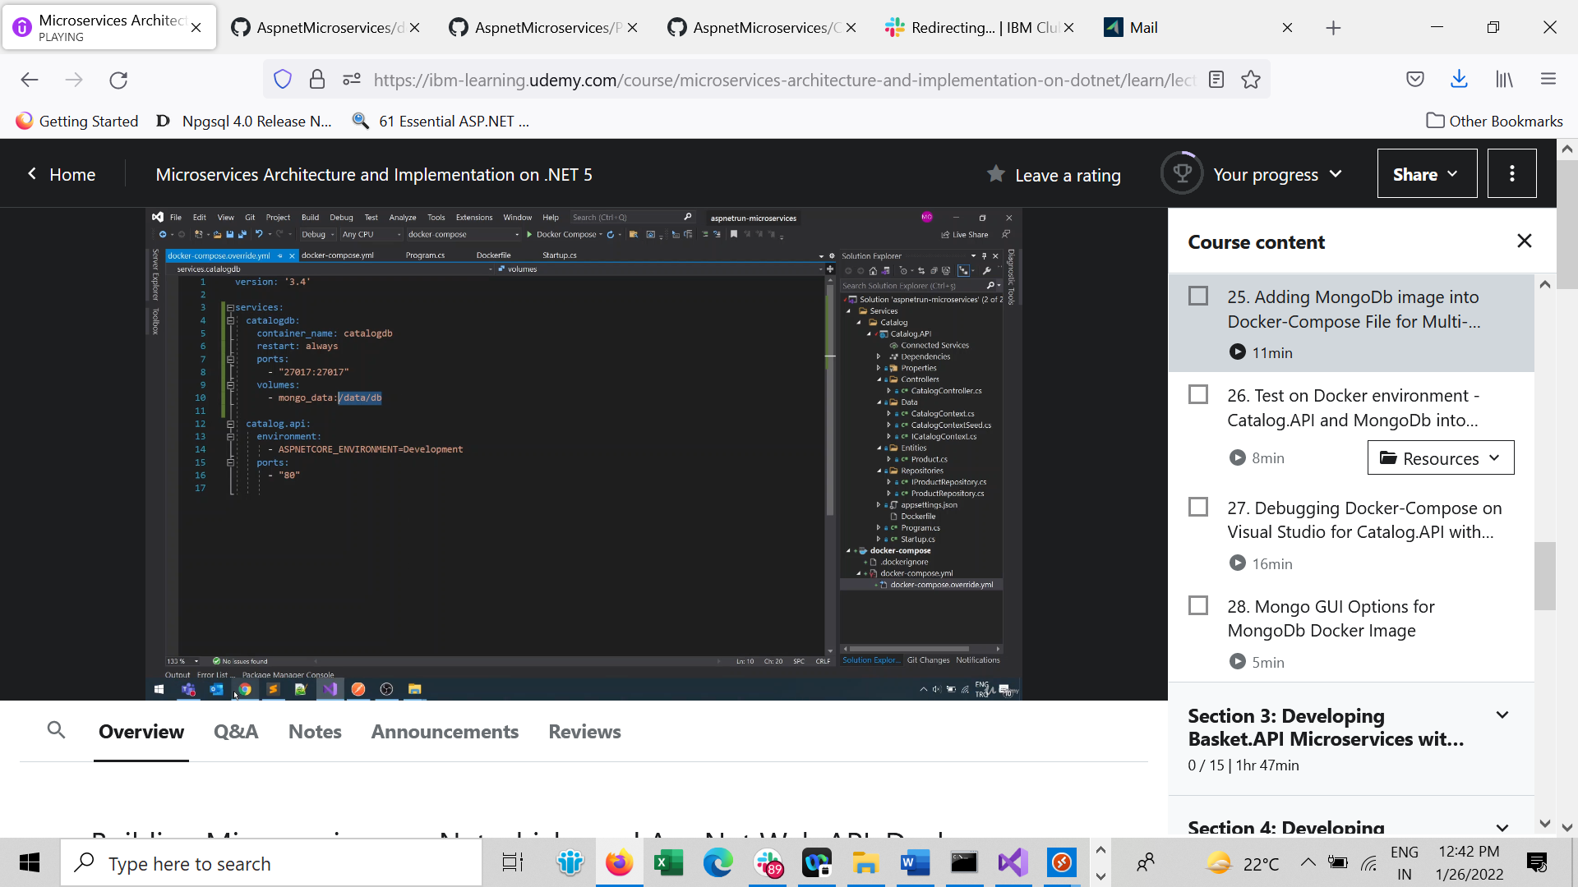

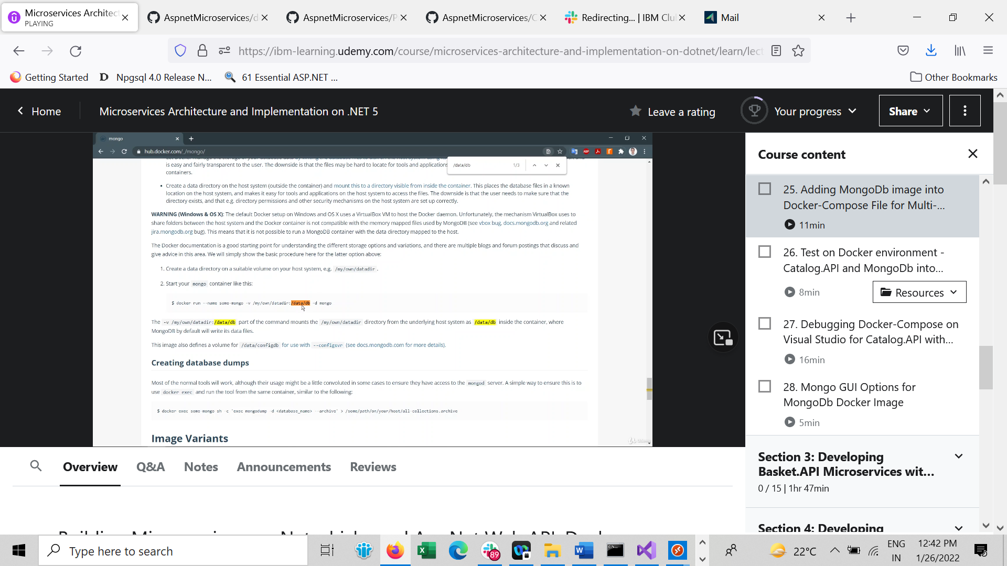

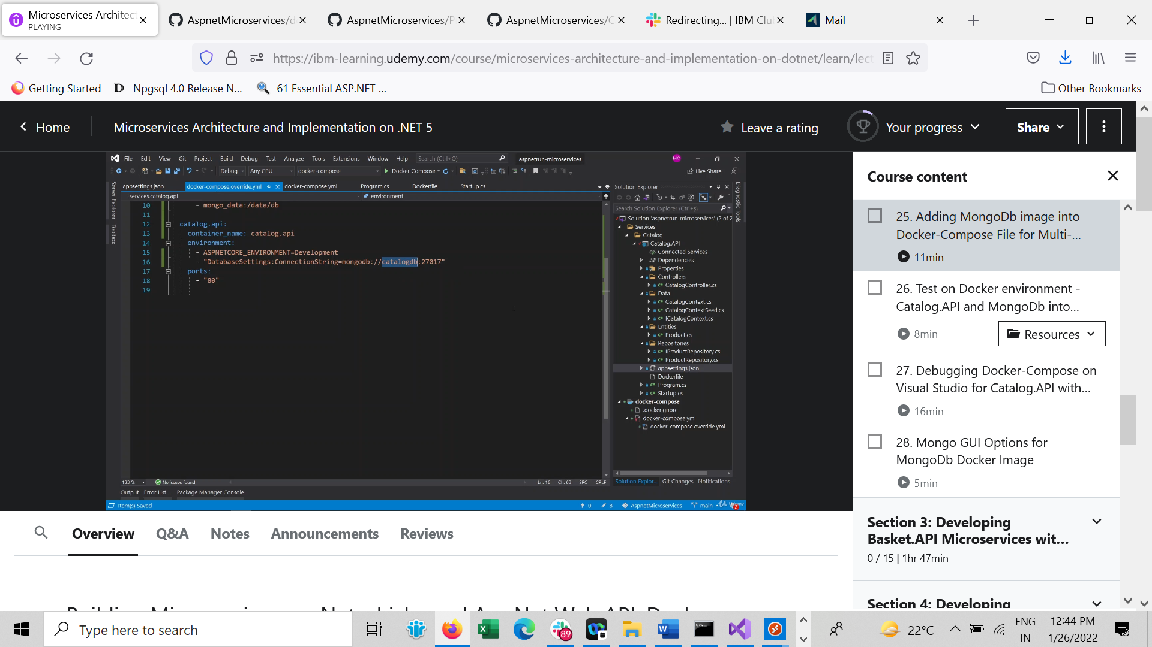

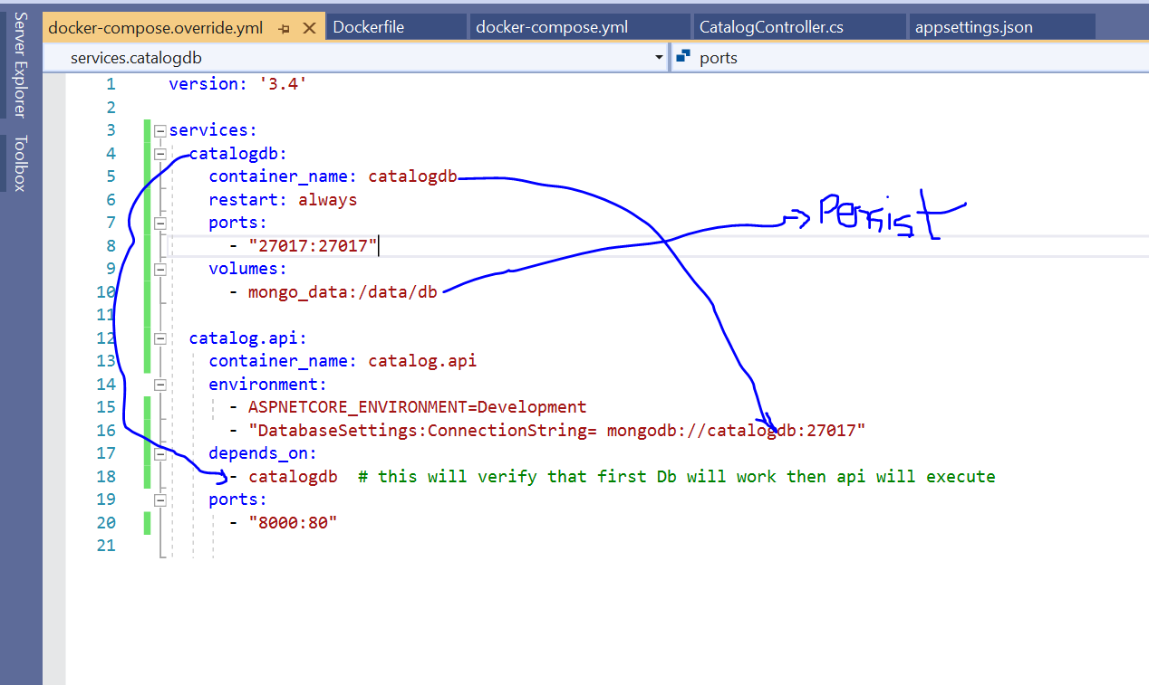

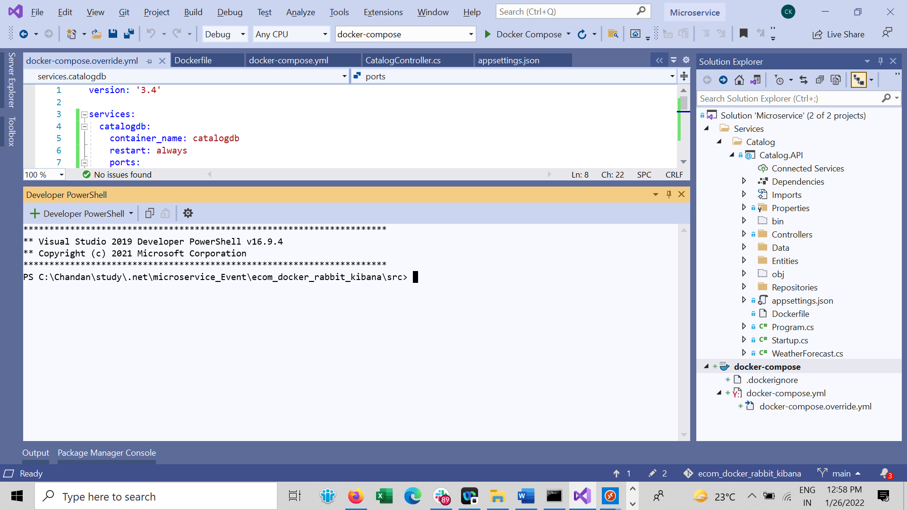

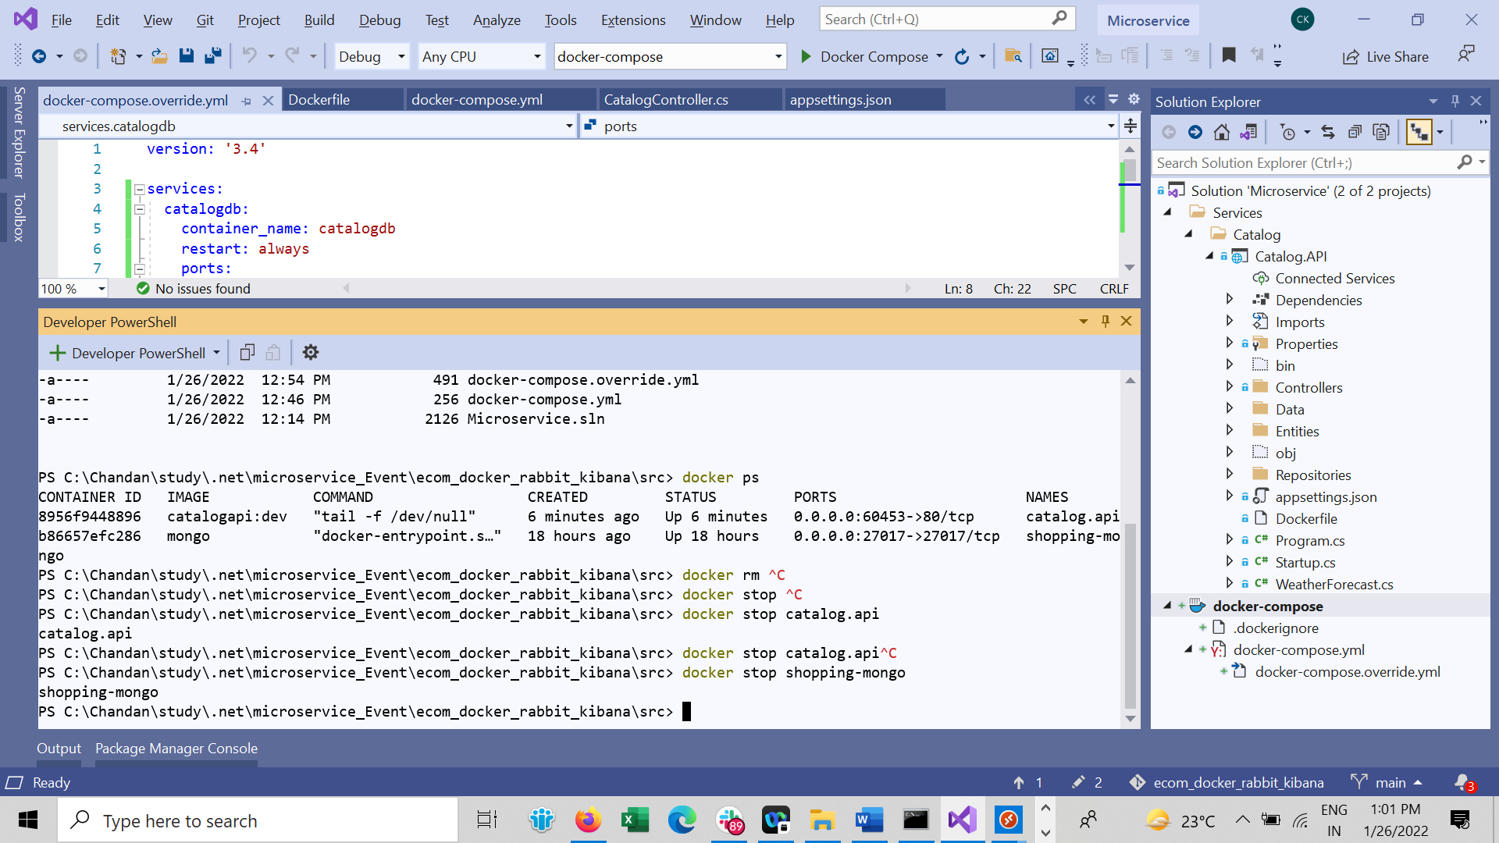

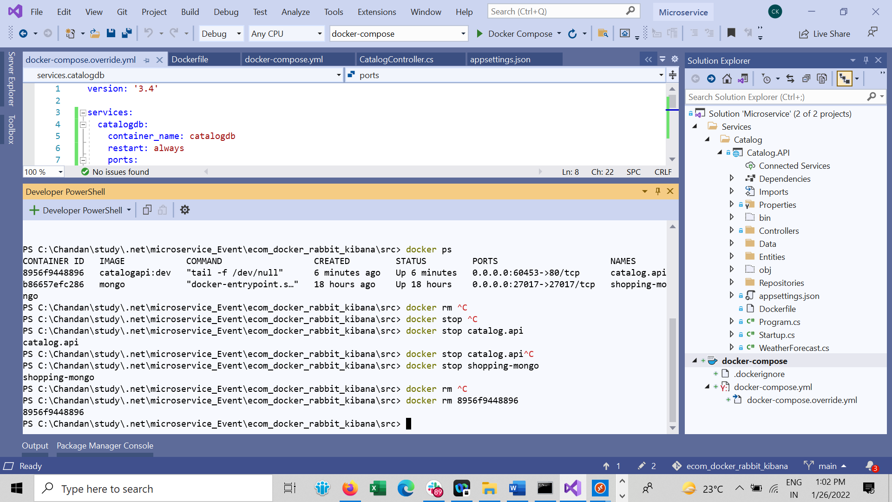

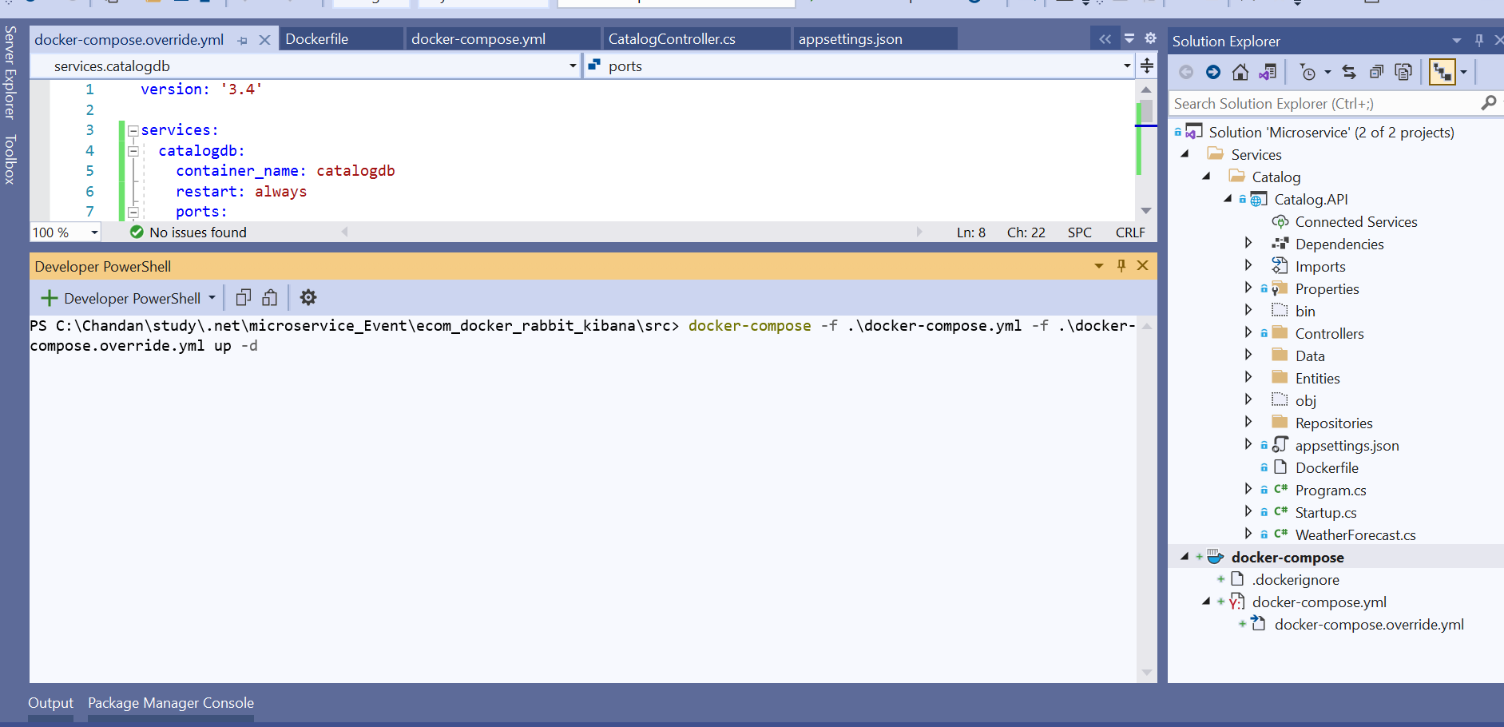

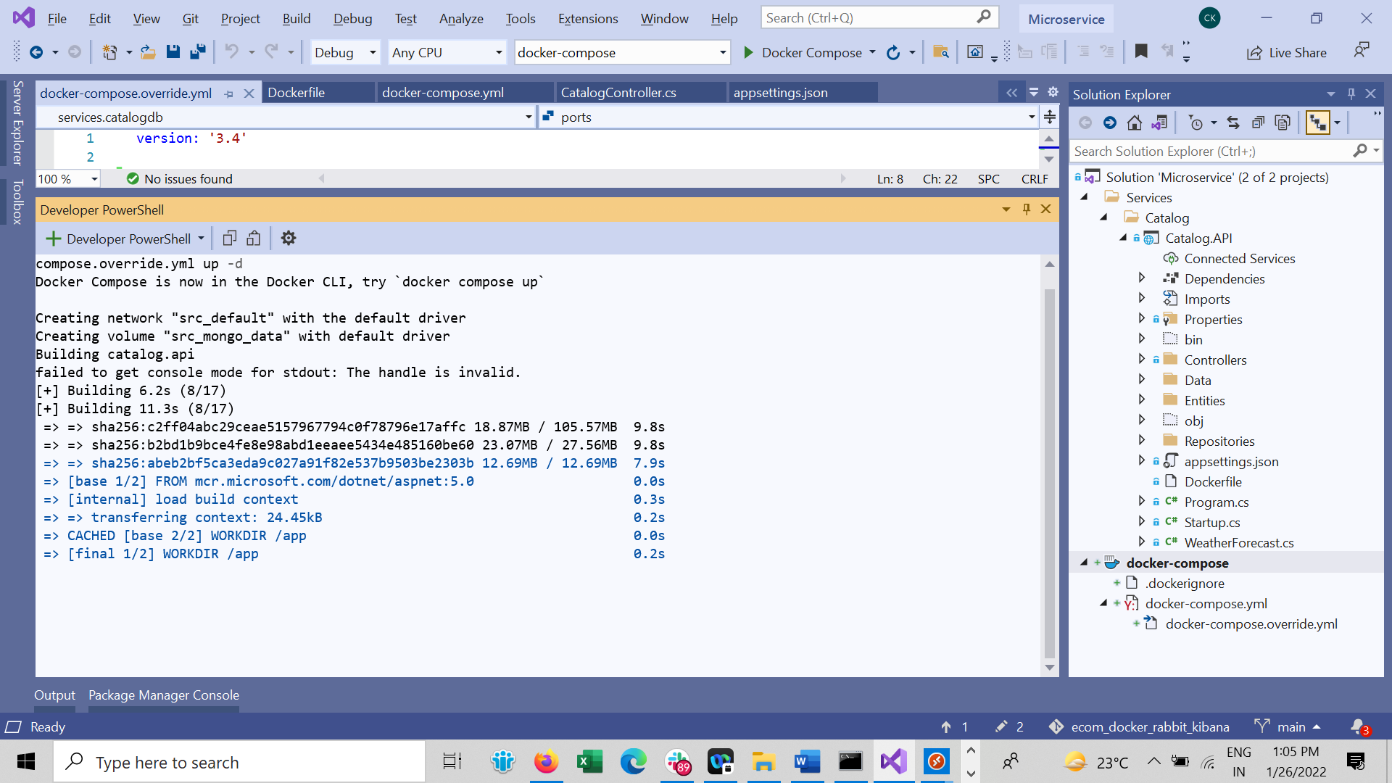

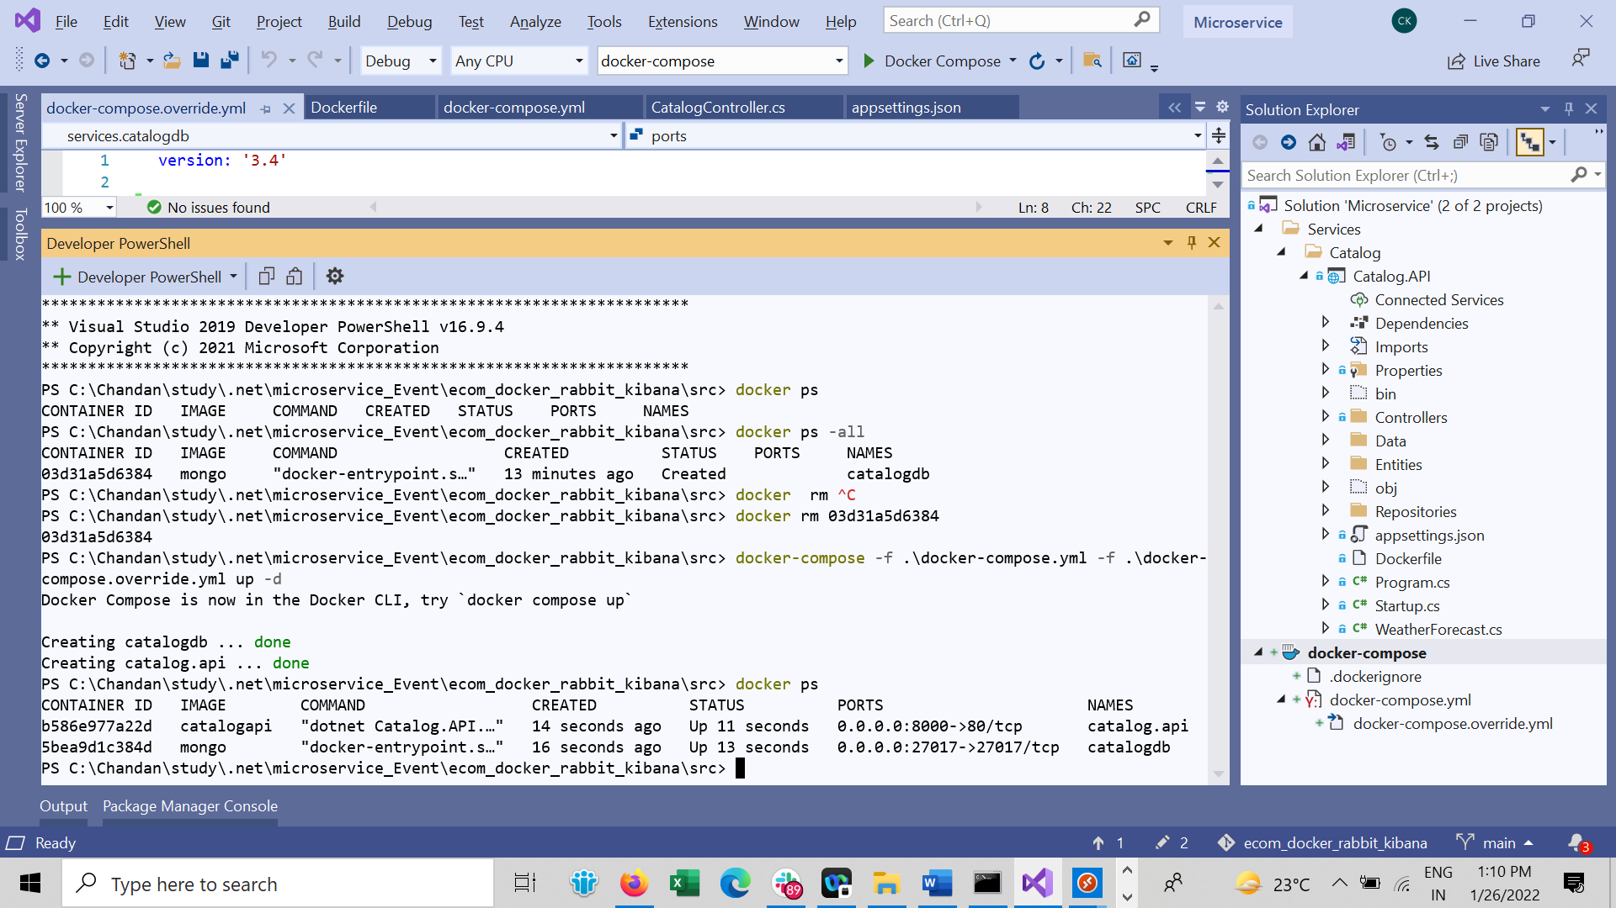

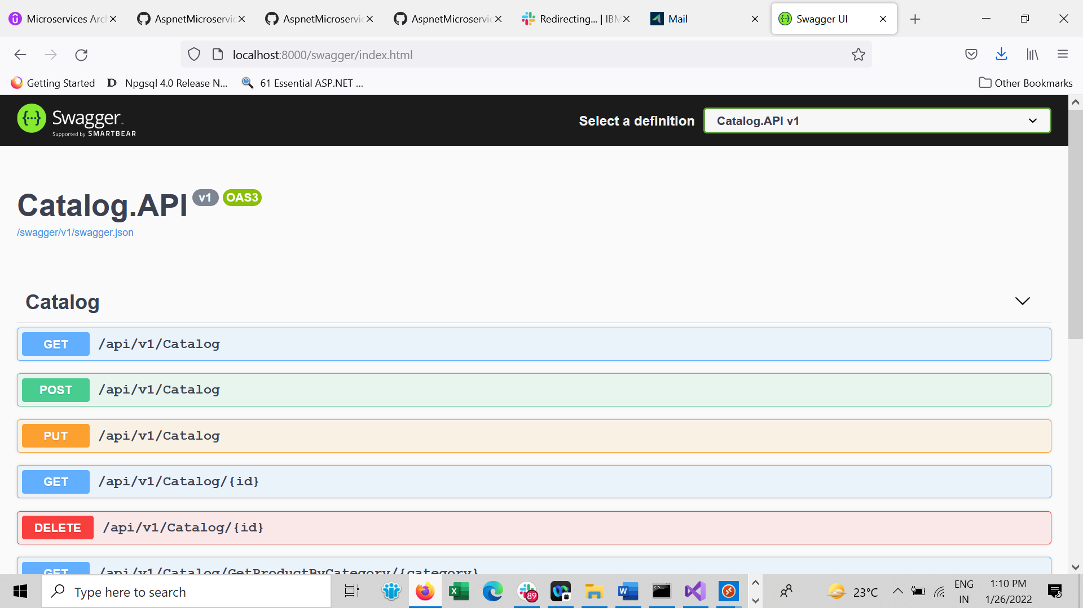

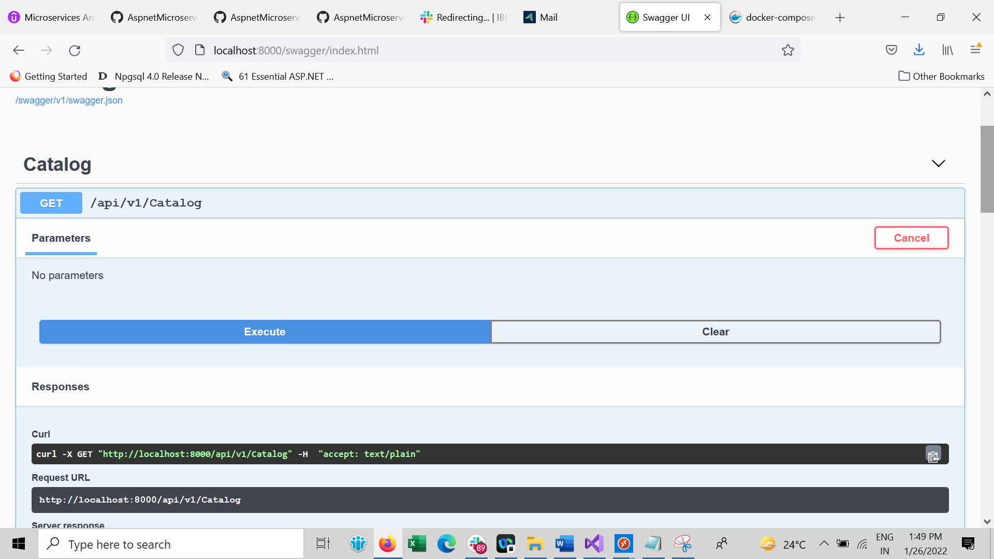

Debugging docker-compose

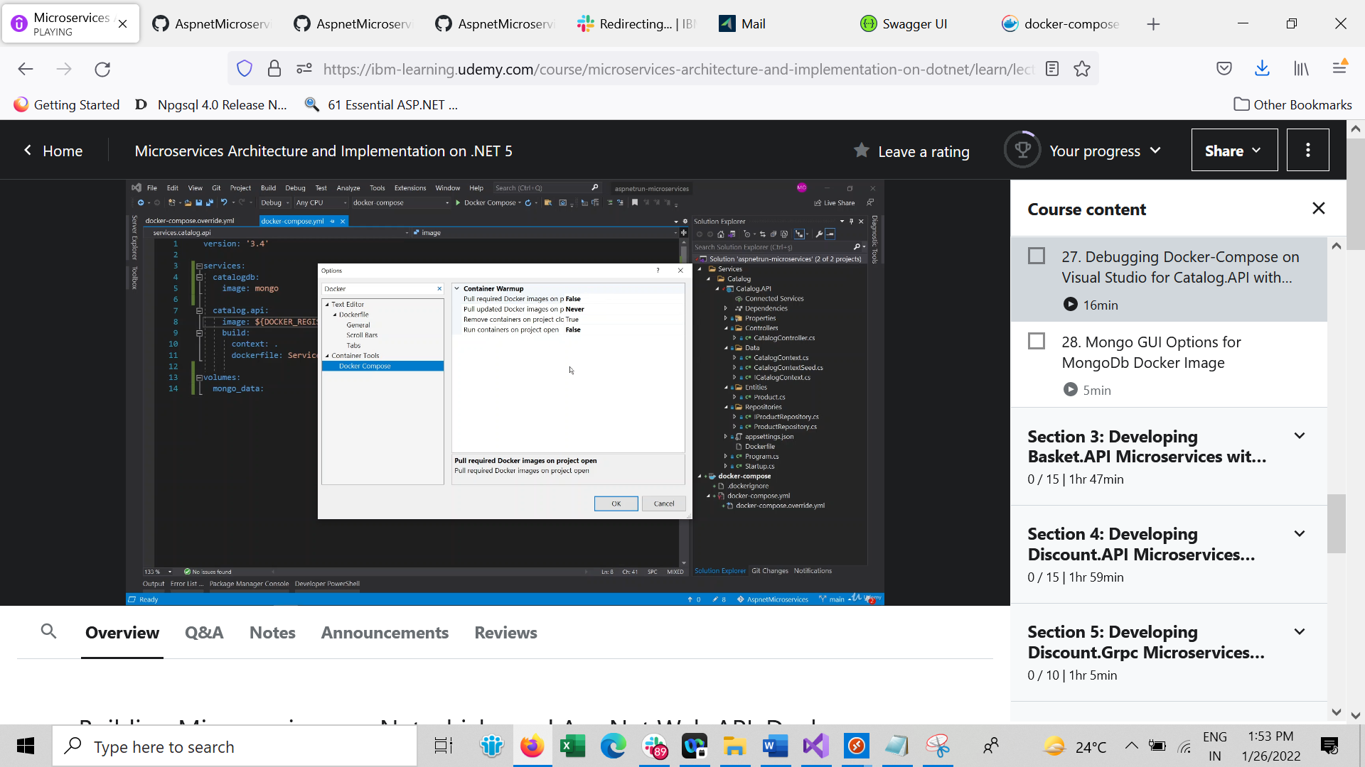

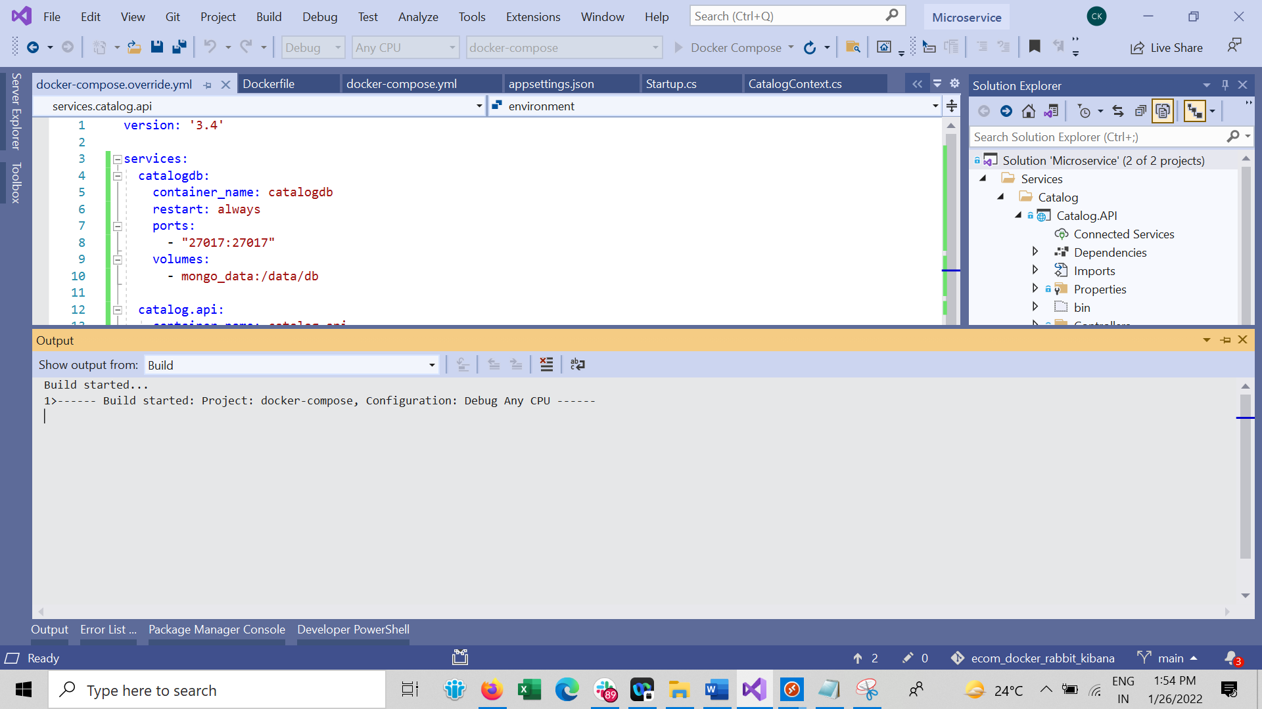

Down all container

docker-compose -f .\docker-compose.yml -f .\docker-compose.override.yml down

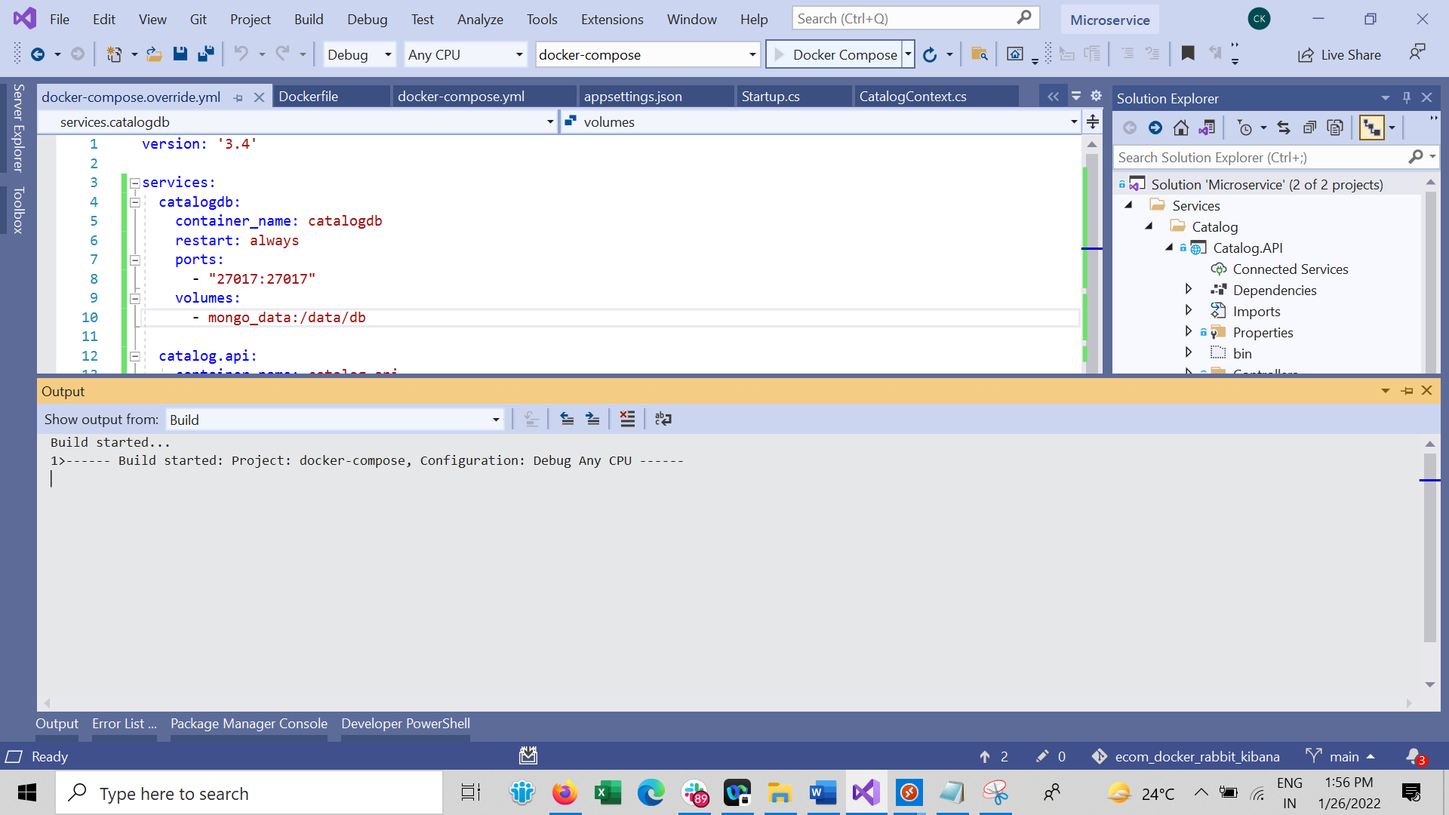

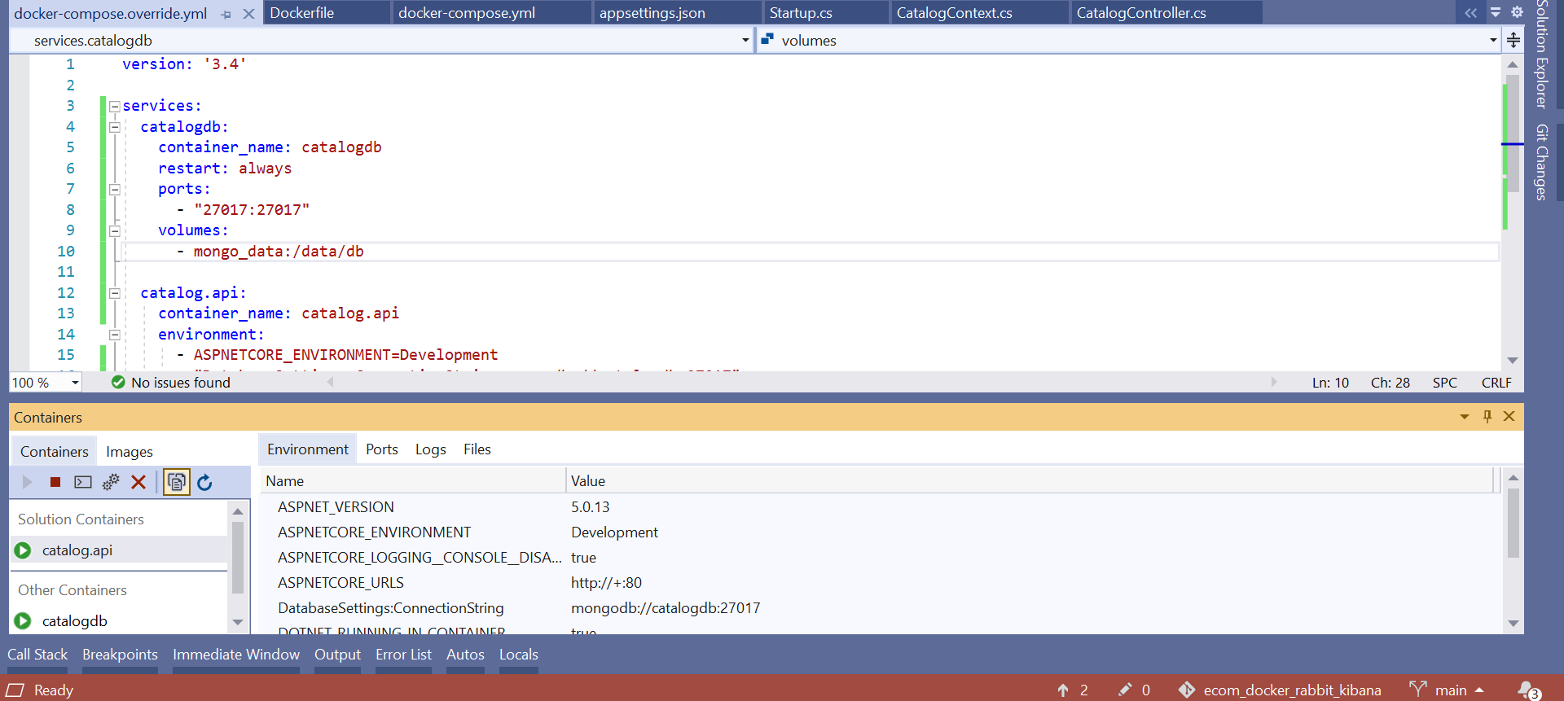

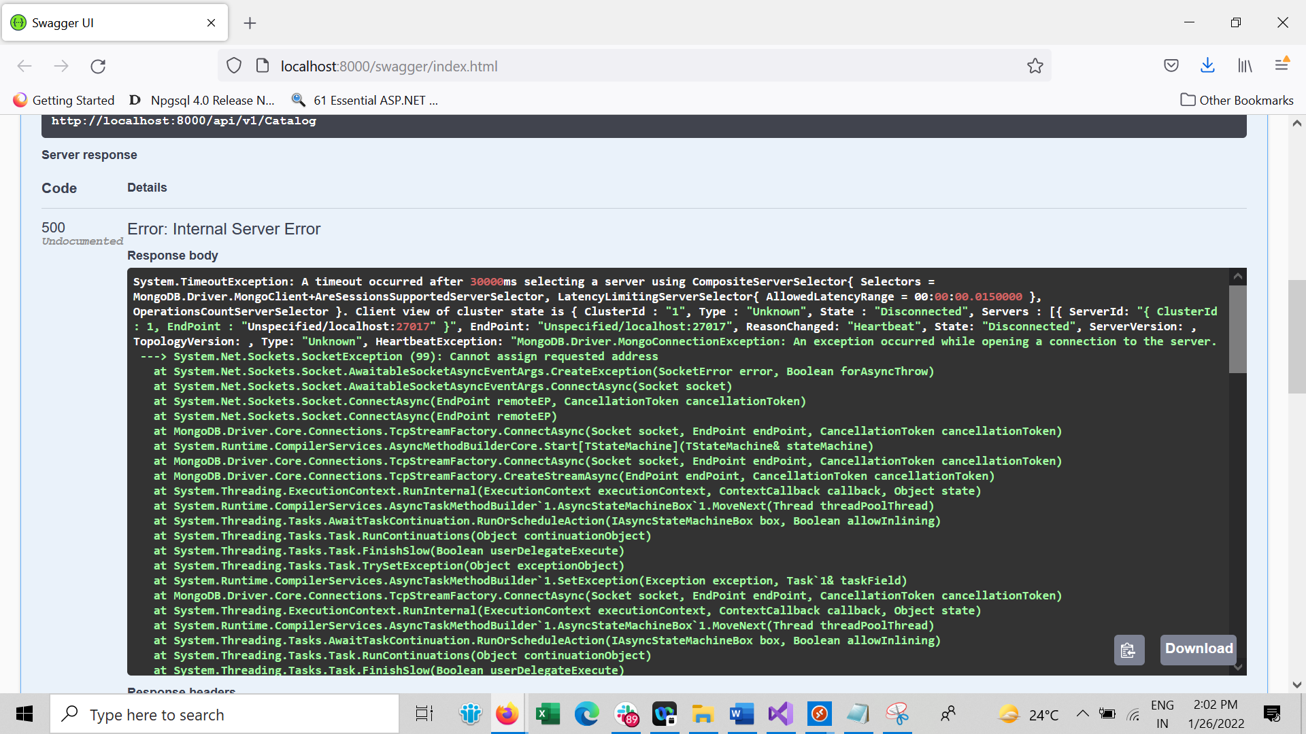

Then , because our envir is Development

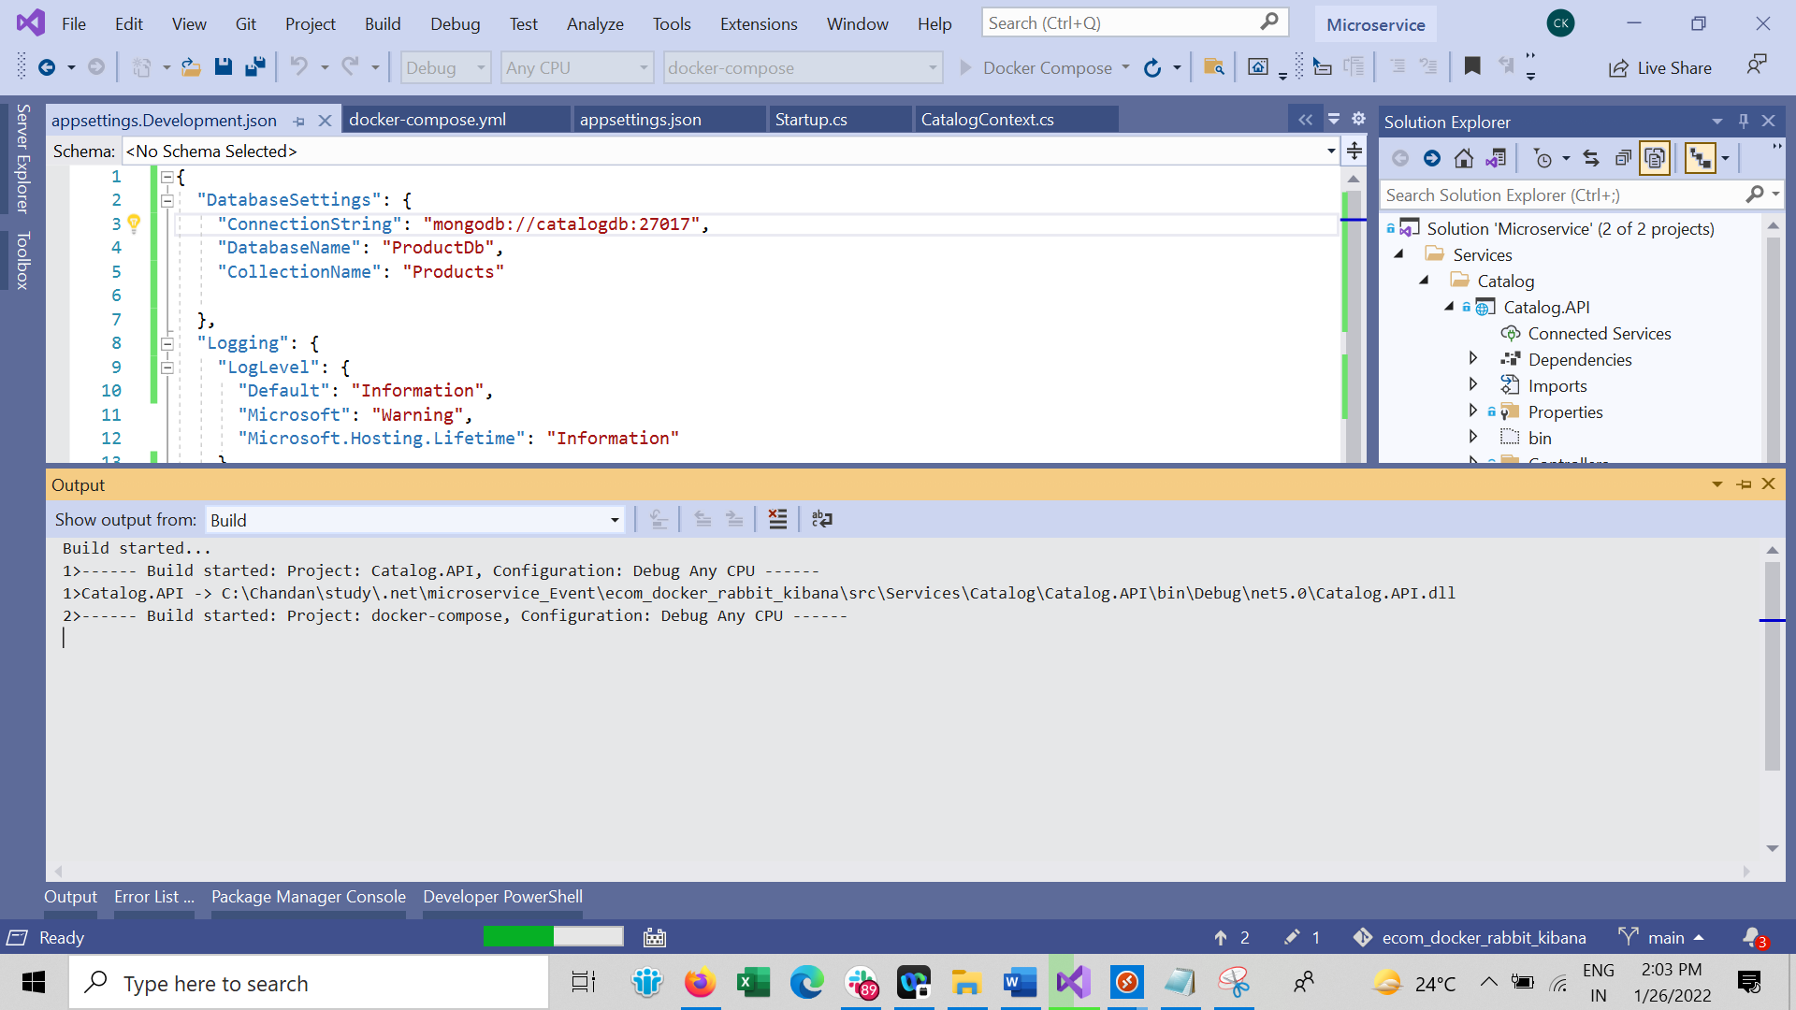

Now stop all container

Docker ps -aq : give list of all running container

docker stop $(docker ps -aq)

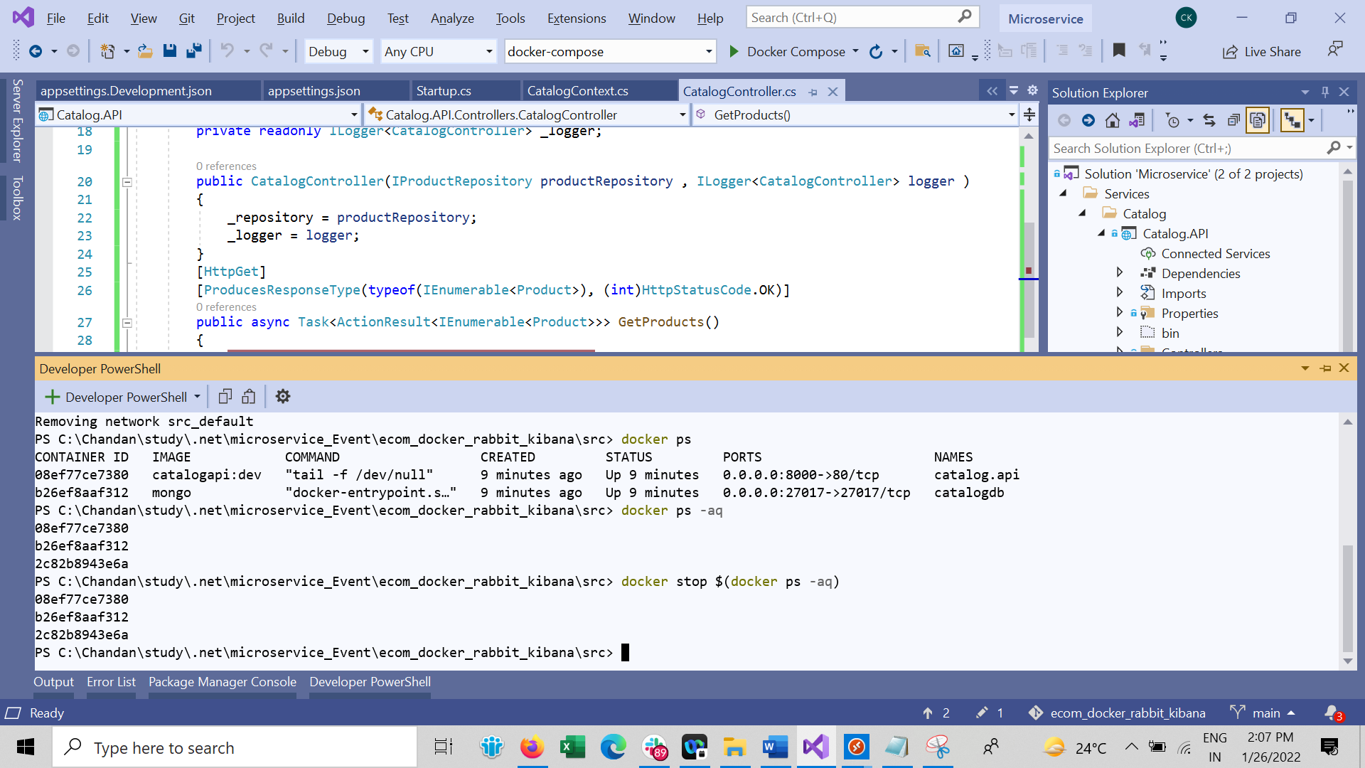

Remove all container

docker rm $(docker ps -aq)

remove all Images

docker rmi $(docker images -q)

to prune

docker system prune

Mongo GUI

docker run -d -p 3000:300 mongoclient/mongoclient

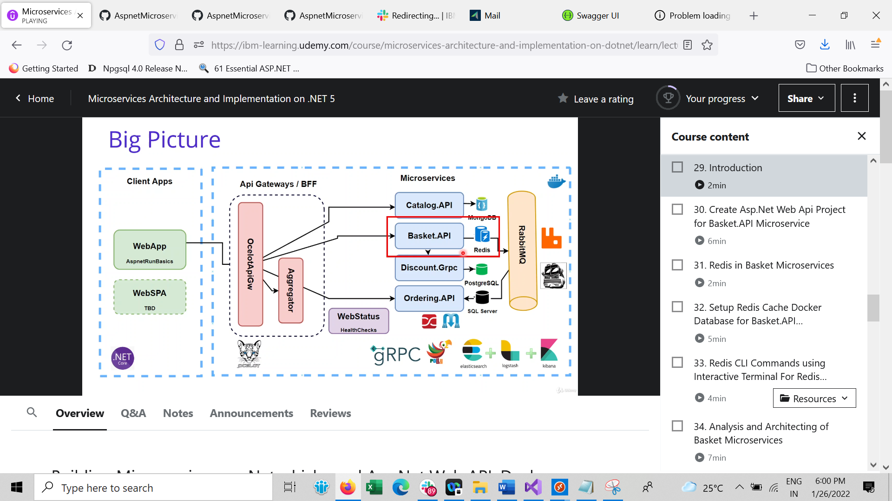

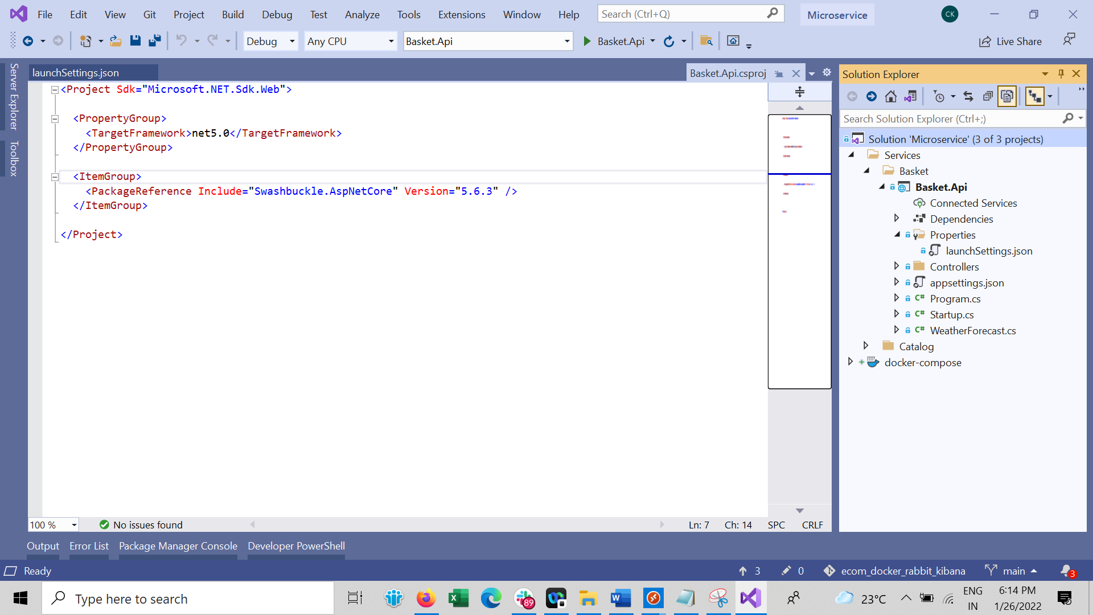

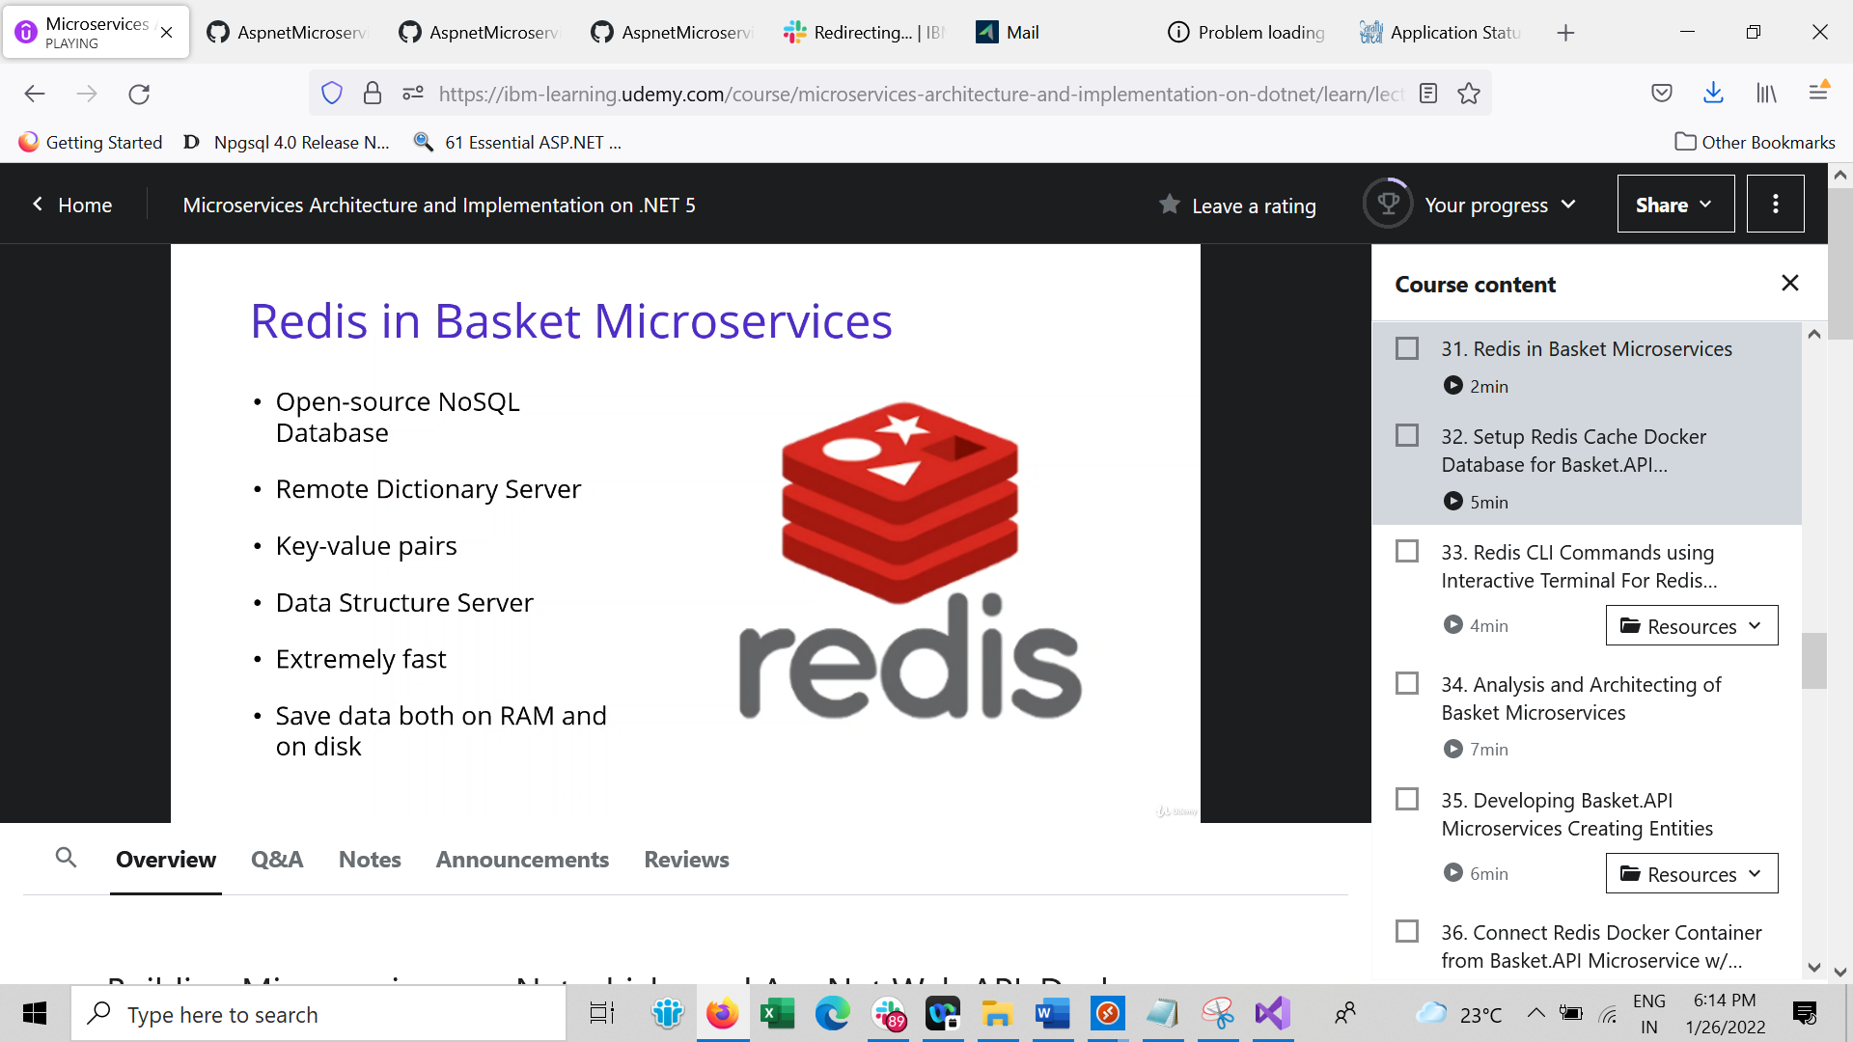

If transaction receives any error there is no return

docker pull redis

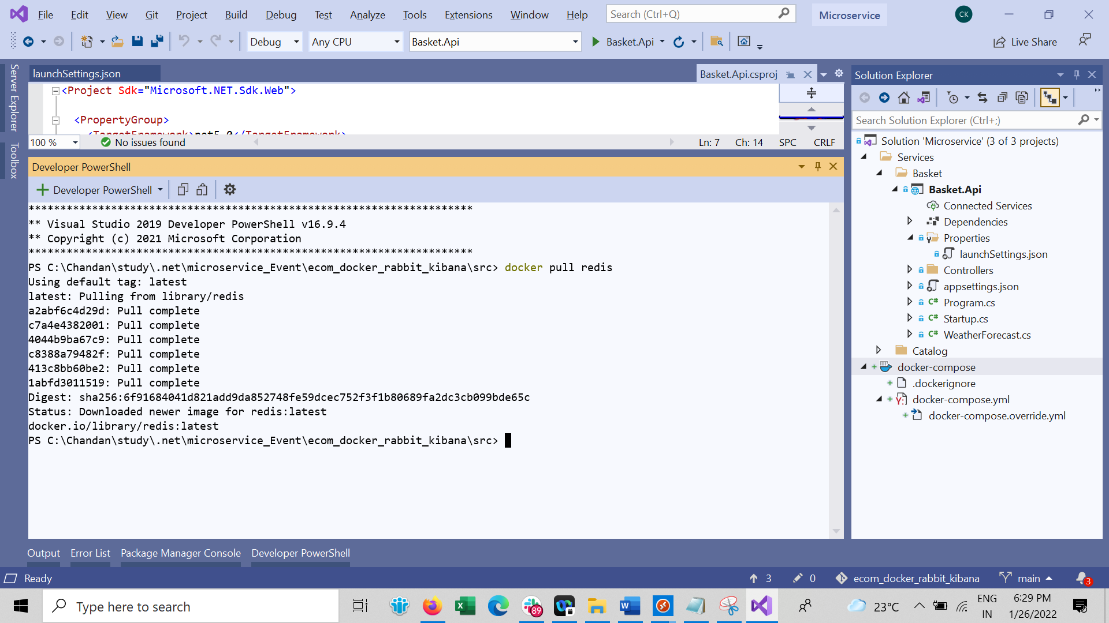

docker run -d -p 6379:6379 --name aspnet-redis redis

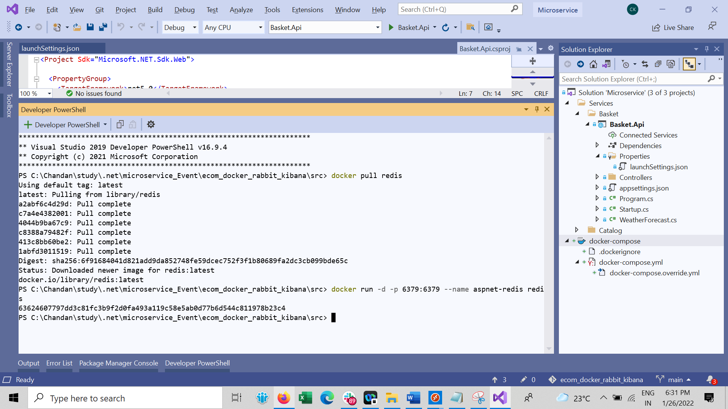

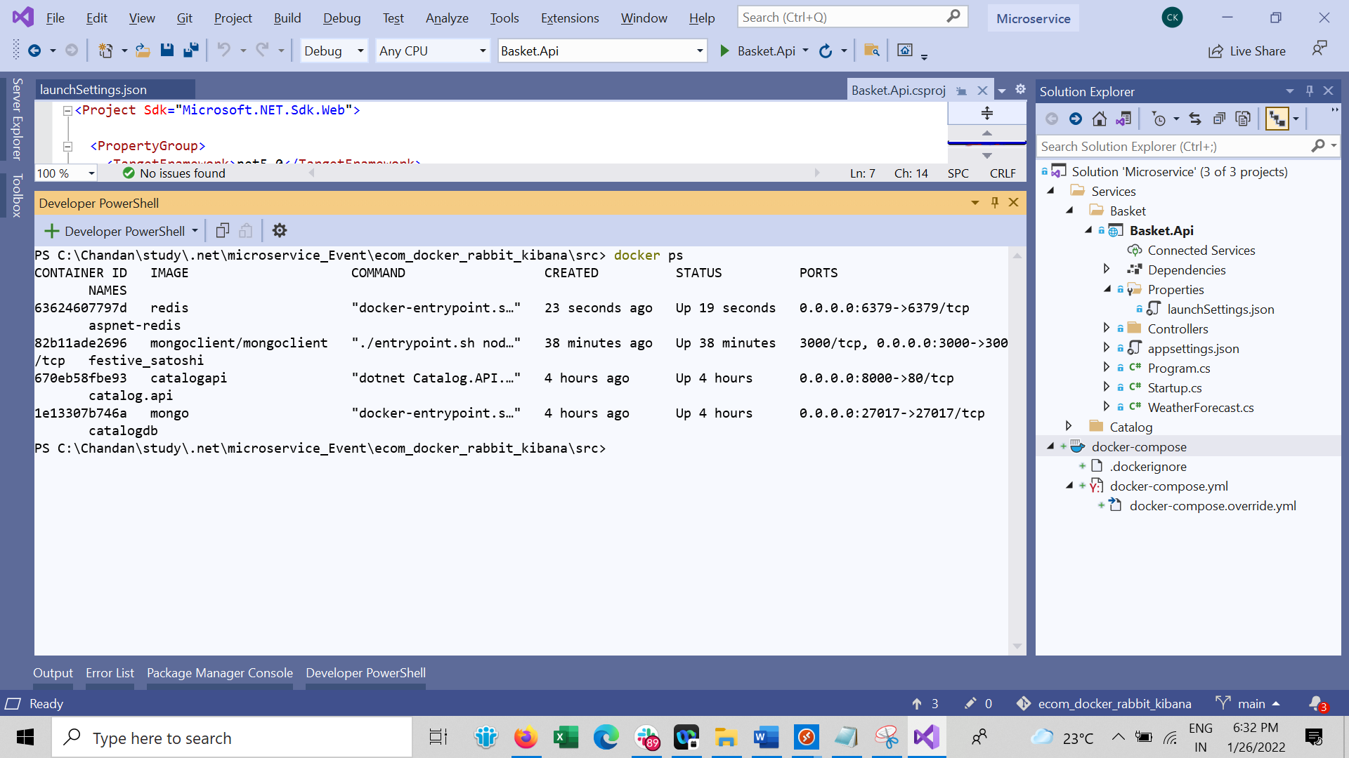

docker logs -f aspnet-redis

docker exec -it aspnet-redis /bin/bash

redis-cli

